Shaping Library
Shaping practice occurs during structured training time and lasts for 1 hour each day. Shaping tasks target the specific movement problems participants are experiencing with their weaker arm, and support them to work towards their goals. Therapists should provide participants with a range of shaping tasks to target different movements. Each shaping task will be completed in a series of timed trials. Each task should last between 30 seconds and 2 minutes and the participant will complete the SAME task 10 times in a row, recording their achievements after each attempt.
Aim to introduce 4-5 shaping tasks in the set-up session on day 1 and prescribe around 8-10 tasks in total within the first week. Participants should do a minimum of 3 DIFFERENT SHAPING tasks per day. Remember to set tasks at a ‘challenging but achievable’ level, avoiding tasks which cause frustration. Participants should be able to complete at least 3 repetitions in 60 seconds on the 1st trial for any task. Copy / paste chosen shaping tasks directly into the participant’s ‘Shaping practice list’ in their Paperwork Pack and edit the tasks as required.
Task:  SHOULDER | Movement encouraged | Task set up and equipment | Original challenge | Increasing / Simplifying the Challenge
Transferring fruit to a bowl | Forward reach and straightening the elbow | - Seated at table  - Fruit (apples, oranges, mandarins) or vegetables (onion, carrot, garlic, potato) x 5-10 or other items that are not perishable e.g. Tennis balls, chip packets, socks  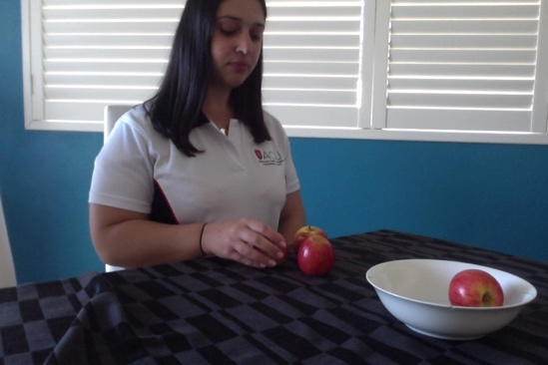  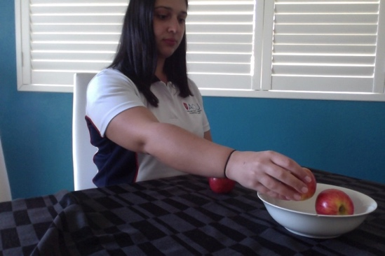  - Bowl | How long does it take you to place all 5 apples into the fruit bowl?  OR  How many times can you transfer 1 apple from the table into the bowl in 1 minute? | - Increasing / decreasing no. of fruit to transfer  - Moving bowl further away / closer  - Using larger / smaller fruit  - Placing bowl at a height e.g. On top of a tissue box /on a stool
Transferring rice/beans from bowls with spoon | Forward reach and control of the elbow | - 2 x bowls  - 1 x spoon  - Rice, beans, dried lentils, pasta, anything of similar size and shape  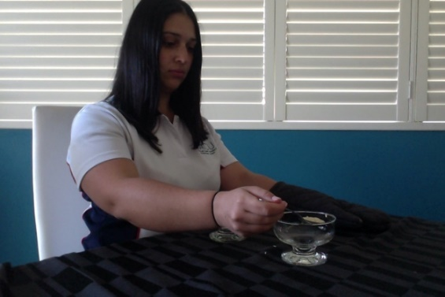  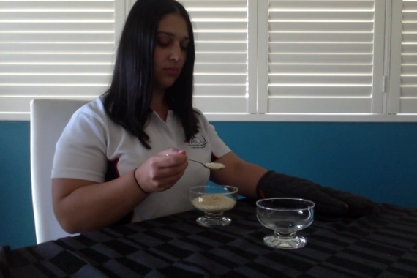 | How long does it take you to transfer all the rice from one bowl to the other? | - Increase/decrease the amount of rice/object being transferred  - Move the bowls further away from each other/closer together  - Place one of the bowls at a height (on a tissue/shoe box) Non-slip mat  - Use an adapted spoon/standard dessert spoon/ teaspoon e.g. bendable /wide handle
Opening a drawer without moving your body | Moving arm back/behind your body | - In standing  - Drawer to open  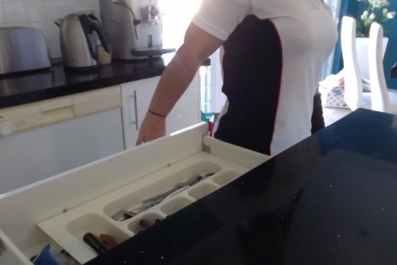  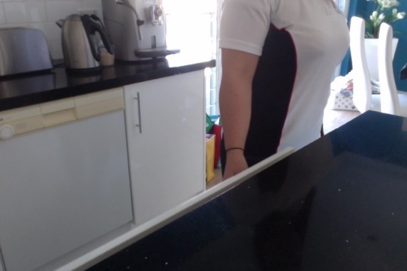 | How long does it take you to open and close the drawer 5 times? | - Increase/ decrease target number of repetitions  - Add in: removing objects from drawer and placing them on the counter behind you/to the side/open drawer half way instead of fully open  - Add more items to the drawer to make it heavier/ Open an empty drawer  - Trying to close the drawer without slamming it shut
Reaching forward for an object and placing it behind you | Reaching in front and behind you,  grasping an object | - In sitting  - 2x tables  - 2x bowls  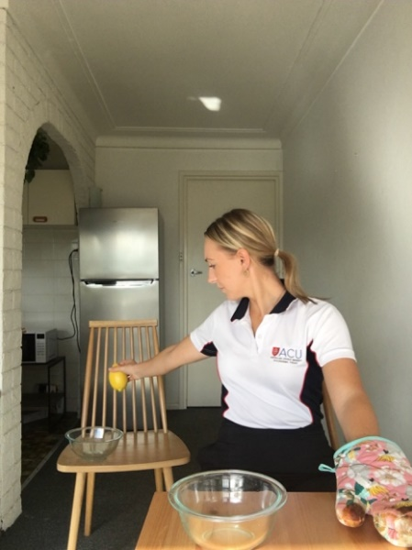  - 5x pieces of fruit (or tennis balls, packets of food, socks)  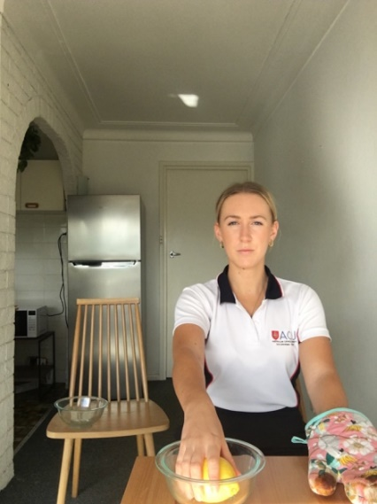 | How long does it take you to transfer 5 objects from the bowl in front of you, to the bowl behind you? | - Increasing/ decreasing the weight of the object  - Increasing/ decreasing the distance of the bowls  - Increasing/ decreasing the height of the bowls on the tables  - Adding in extra objects/ decreasing number of objects transferred
Loading/ unloading washing machine | Forward reach, bending and straightening elbow | - Washing machine and clothes  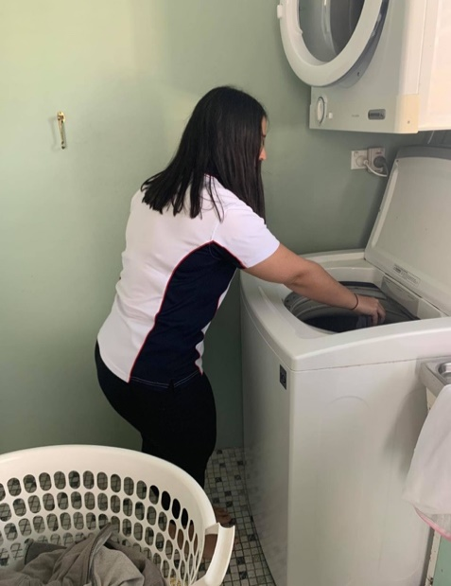  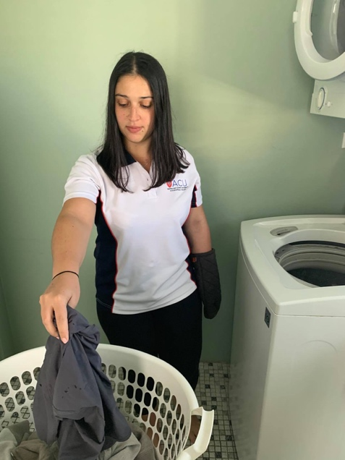 | How many items of clothing can you put in the machine in 30 seconds? | - Basket on floor  - Using wet washing to challenge strength  - Taking clothes out of machine as well as putting in the machine  - Loading into drier (if at a higher height)  - Increase time and number of pieces of clothing  - Stand further away/ closer to machine  - Incorporate larger/heavier objects of clothing/ start with small pieces of clothing or dry (lighter clothes)
Underarm and/or overarm throwing against wall | Shoulder and arm movement | 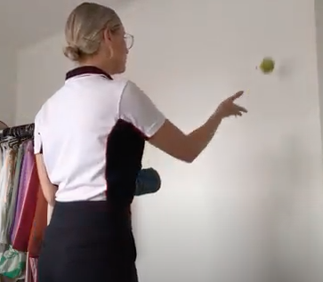  - 1 x small ball and flat wall to throw the ball onto  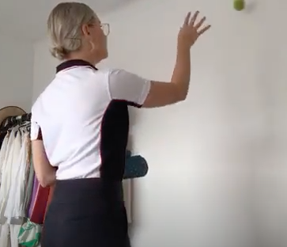 | How many underarm throws and catches of the ball against the wall can you do in 30 seconds?  OR  How many overarm throws and catches of the ball against the wall can you do in 30 seconds? | - Start with underarm throws, progress to over arm throws  - Increase/decrease time component  - Go from lighter to heavier ball  - Stand further away/closer to the wall  - Add in targets on the wall to hit to increase accuracy
Taking hat on and off | Shoulder range | - In sitting  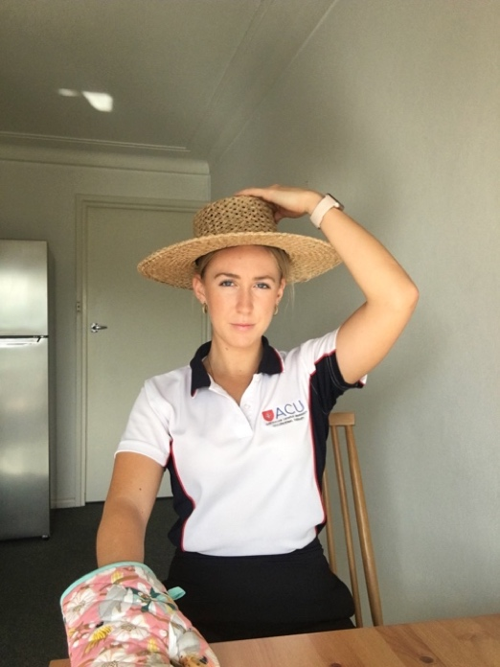  - Hat or beanie  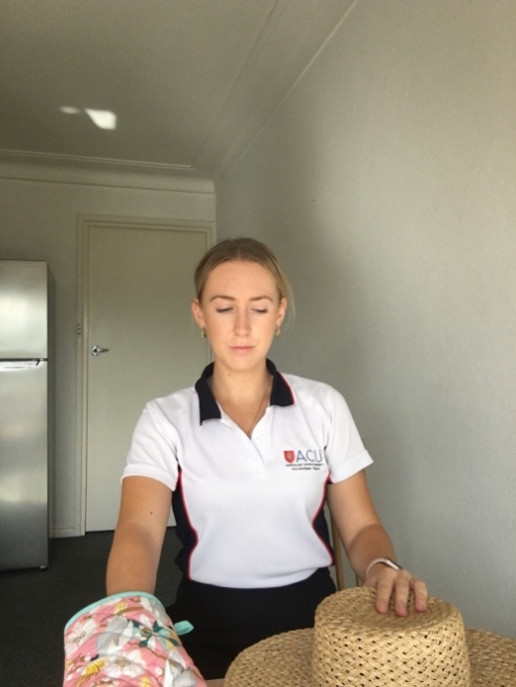 | How many times can you put on and take off your hat in 30 seconds, placing it on the table in front of you each time? | - Increase the duration  - Increase/decrease weight/size of hat e.g. large sun hat vs small, light cap, loose beanie  - Sit up straight or lower starting point to increase range hat has to be moved/allow the body to move forward to meet the hat
Putting coins from the bench into your pocket | shoulder control, dexterity and sensation in hand | - Coins x 10-20  - Bunch of keys  - Kitchen bench or table  - Pants / trousers with large pockets / easy to access pockets or a handbag with long strap  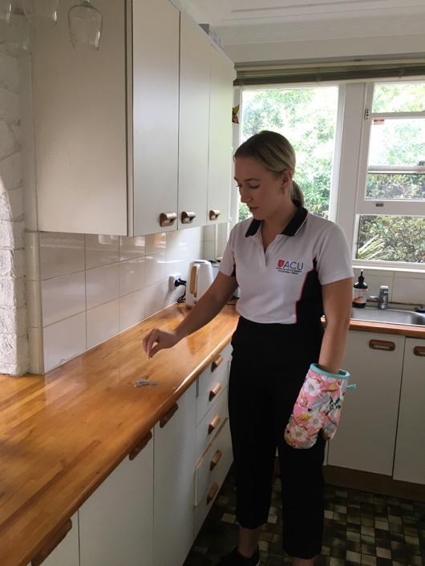  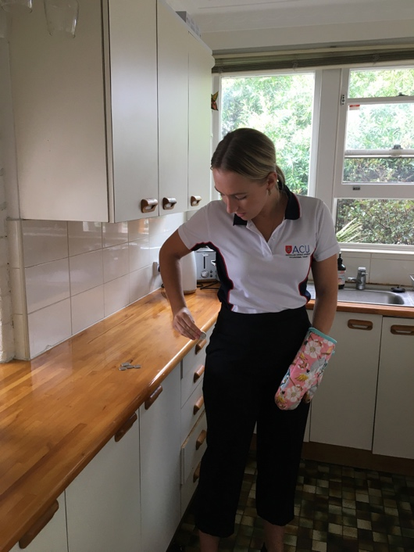 | How many coins can you pick up off the bench and place into your pocket/handbag within 30 seconds? | - Increase the size/weight of the object e.g. phone  - Reduce/ increase size of object e.g. small coins vs coins or poker chips  - Increase the time (endurance)  - Increase/ decrease distance from table to pocket  - Progress difficulty of type of pockets e.g. Jeans pockets  - Use a non-stick mat or bowl to pick up coins bowl to pick coins up from
Getting objects off the shelf | Shoulder strength, reach and control | - In standing  - Kitchen bench  - Cupboard  - Object to hold e.g. mug, cup, jar/can of food  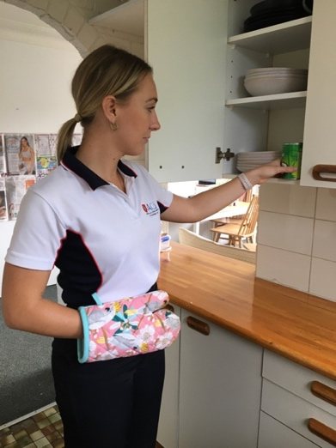  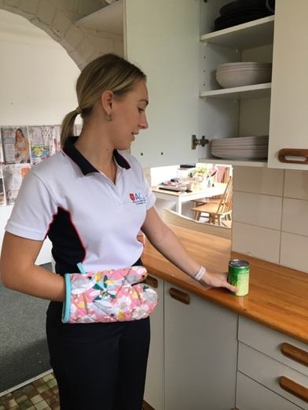  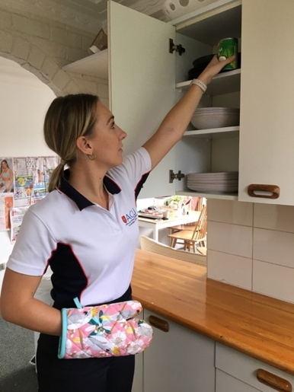 | How many times can you place the item on the shelf and return it to the bench within 30 seconds? | - Make the object heavier/ lighter e.g. can vs empty cup, spice jar  - Increase/ decrease height that the object must be moved e.g. higher vs lower shelf  - Increase task duration Make the object easier to grasp e.g. near empty packet of flours
Transferring apples from the table to the fruit bowl | Shoulder range and control | - In sitting  - 5 x apples (or socks, balls, small packets of food)  - 1 x bowl  - Make sure your elbow stays resting on the x on the table at all  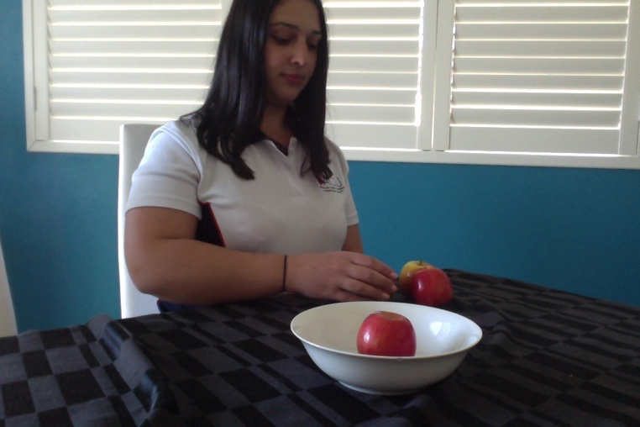  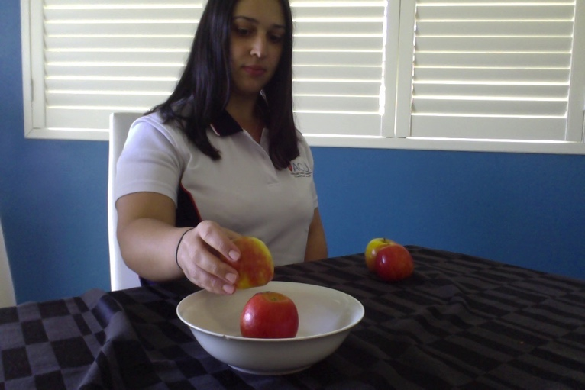 | How long does it take you to transfer 5 apples from the table to the bowl? | - Increase/ decrease the distance between the starting point and the bowl  - Increase/ decrease the number of apples to transfer  - Introduce a reach component  - Increase the height of the bowl e.g. with a tissue box, to introduce reach  - Decrease number of apples to transfer  - Easier object to grasp e.g. piece of ginger
Drawing a rainbow / arc | Shoulder range and control | - Paper  - Pencil / marker – possibly multiple colours for potential increase of challenge  - Make sure your elbow stays resting on the x on the table at all times  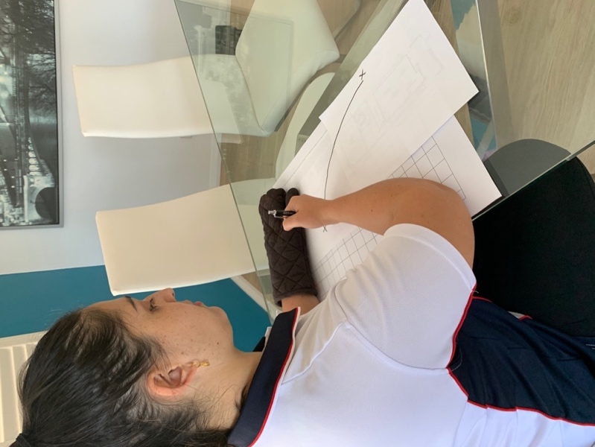 | How many times can you draw a line from point A to point B within 30 seconds? | - Move the targets (A-B) further away or closer together  - Increase duration to challenge endurance  - Drawing a rainbow with colour – picking up different coloured pens every time you get back to A  - Use different objects to move from point A to point B e.g. a small ball, a small cloth
Task:  ELBOW | Movement encouraged | Task set up and equipment | Original challenge/What to measure | Increasing / Simplifying the Challenge
Rocking a chair back and forth | Bending and straightening elbow | - Chair with 4 legs  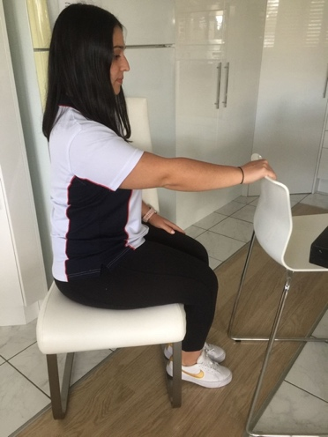  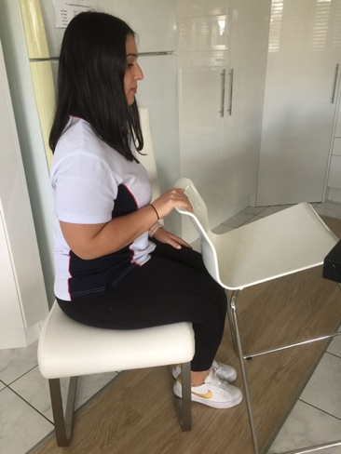  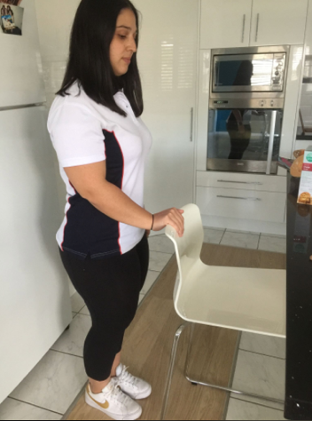  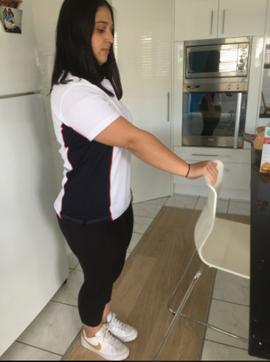 | How many times can you rock the chair back and forth in 30 seconds? | - Increase duration to challenge endurance  - Start in sitting, progress to standing  - Use a different chair that enables further range of elbow straightening  - Trial with a heavier chair to challenge strength  - Chair to make no sound when tipping the chair back onto 4 legs (indicating better elbow control)
Bringing Finger food from plate to mouth | Bending and straightening elbow | - Sitting at a table with a plate  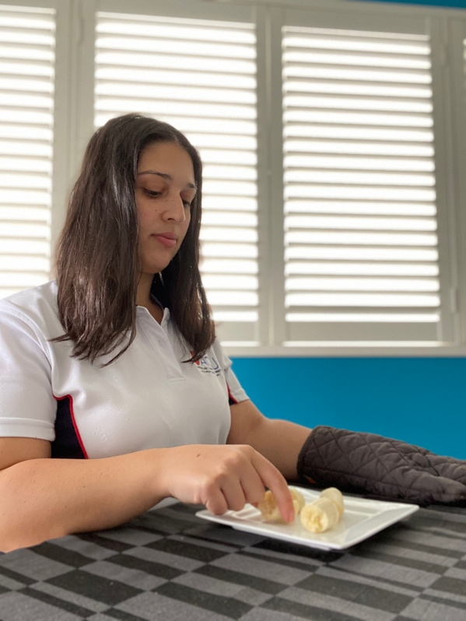  - Small dry foods such as crackers, small blocks of cheese, cut up pieces of fruit, pasta  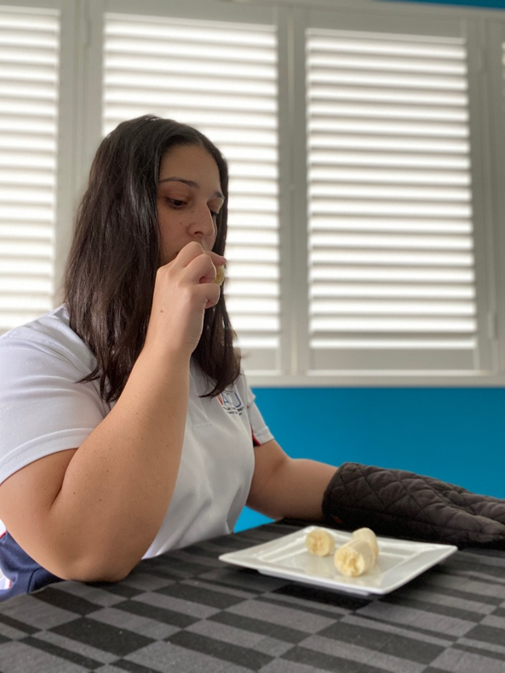 | How many times can you bring the piece of food up to your mouth and back down to the plate in 1 minute? | - Increase/decrease the time goal  - Increase/decrease the weight of the food, to challenge strength  - Release grasp and pick up food again on every repetition  - Start with simulating holding food but not actually holding anything/tape a light object in the hand if unable to grasp a piece of food and progress to holding food
Bringing water on a spoon to your mouth | Elbow/forearm movement when bringing objects to your mouth | - 1 x bowl with water and 1 x spoon  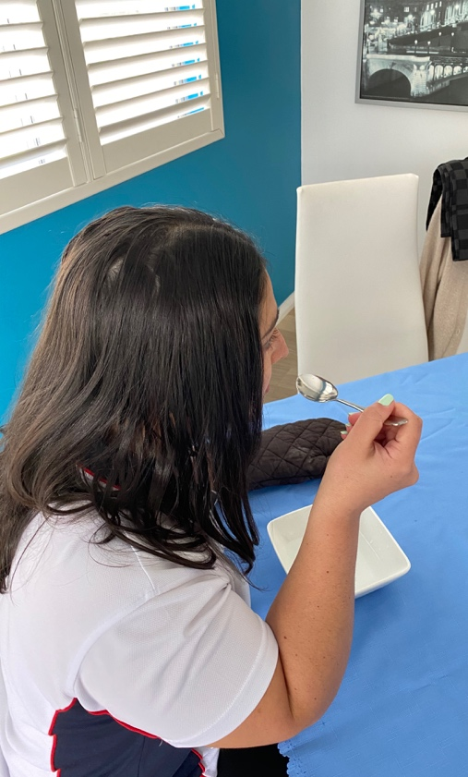  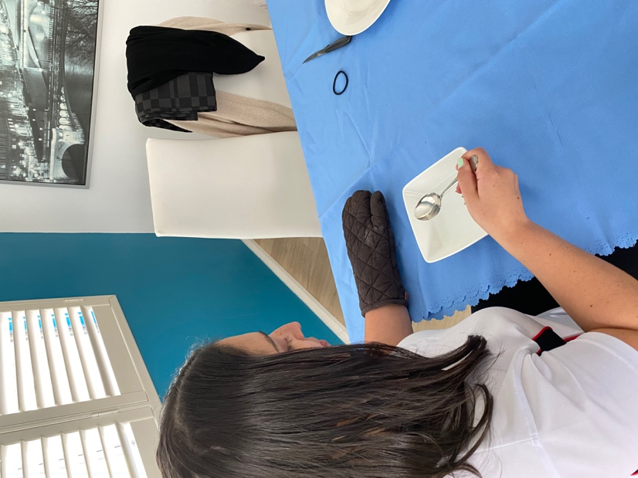 | How many times can you scoop the water onto the spoon and bring it to your mouth and back without spilling any water in 30 seconds? | - Start with no water on the spoon  - Allow spillage and progress to no spillage when able  - Increase/decrease time goal
Taking cards out of top pocket of shirt | Bending and straightening elbow | - Shirt with breast pocket  - Deck of cards or anything that will fit in your pocket e.g. coins, pens  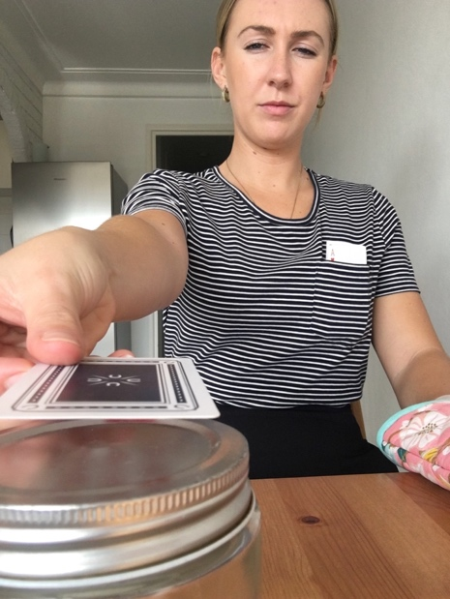  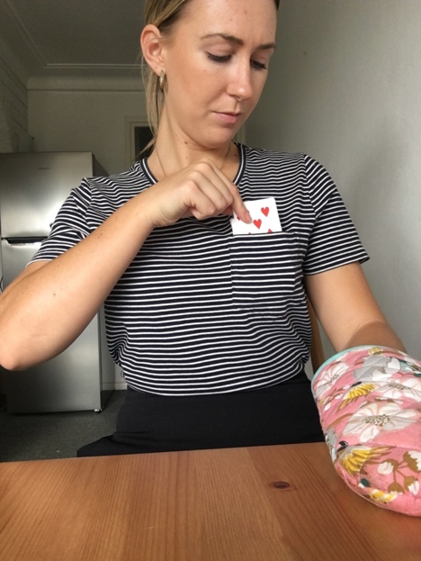 | How long does it take you to place 10 cards from your top pocket to the table? | - Increase/decrease number of cards to be taken out of pocket  - Increase height of object cards are being placed on  - Move target to place the cards on further away or closer together  - Increase the weight of the object e.g. mobile phone rather than cards  - Allow to slide card to edge of table to pick up  - Start with cards in a pile on the table then progress to using pocket
Task:  FOREARM | Movement encouraged | Task set up and equipment | Original challenge/What to measure | Increasing / Simplifying the Challenge
Pouring a cup of water into another cup | Using your forearm (turning it over and back again) | - 2 x cups  - Water  - Grid (optional)  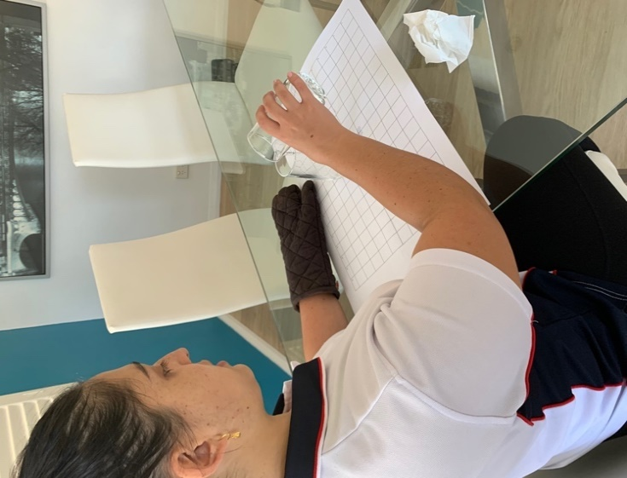  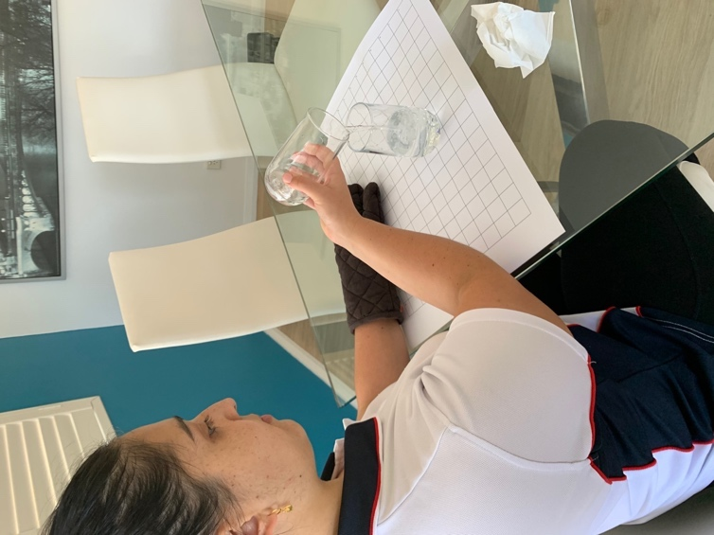 | How many times can you pour all the water from one cup to the other within 30 seconds? | - Add more water to increase range  - Start with elbow on table progress to lifting elbow off table  - Increase duration to challenge endurance  - No spillage  - Standing up  - Use larger glasses / jugs  - Decrease amount of water  - Use dried food e.g. rice  - Use shorter glasses /doughnut easy grip sports bottle lid removed
Flipping/ turning cards | Using your forearm (turning it over and back again) | - Deck of cards or cards from your wallet (credit cards, rewards cards etc.)  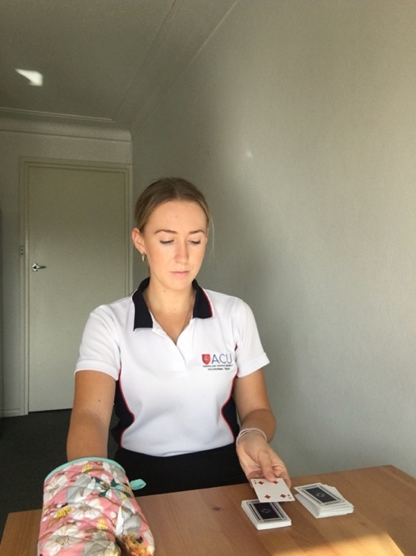  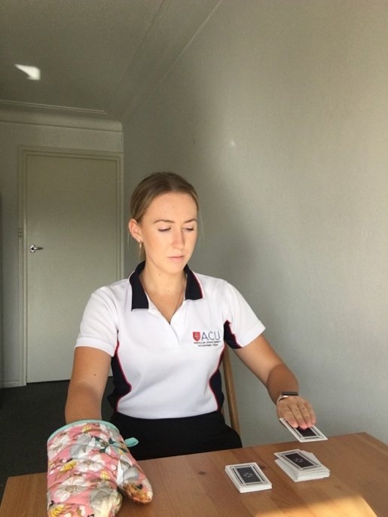 | How long does it take you to flip/turn over 10 cards? | - Increase/decrease number of cards to flip to challenge endurance  - Move card stacks further apart to incorporate bending and straightening elbow  - Neat pile  - ‘Dealing to the table’  - Allow to slide cards to edge  - Allow not neatly piled
Turning pages of magazine | Forearm movement | - Magazine  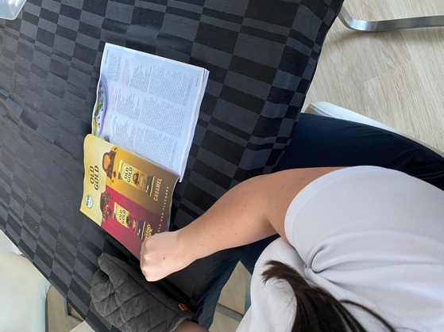  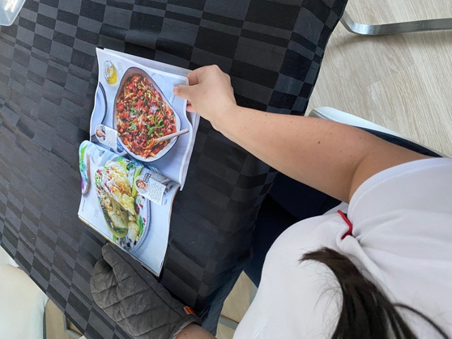 | How many pages of the magazine can you turn in 45 seconds? | - Increasing/decreasing time goal to challenge endurance  - Using different /larger paper types e.g. broadsheet newspaper is thinner and harder to grip and turn  - Using wet fingers to aid page pick up  - Opening front cover only with e.g. rubber between first page and cover for easier pick up  - Bend corners over
Scooping rice up in hand | Forearm movement | - 2 x bowls  - Rice or dried lentils or small pasta or nuts or any other small food objects of the same size/weight  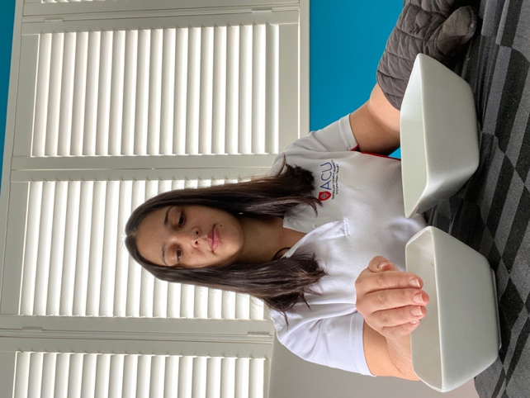  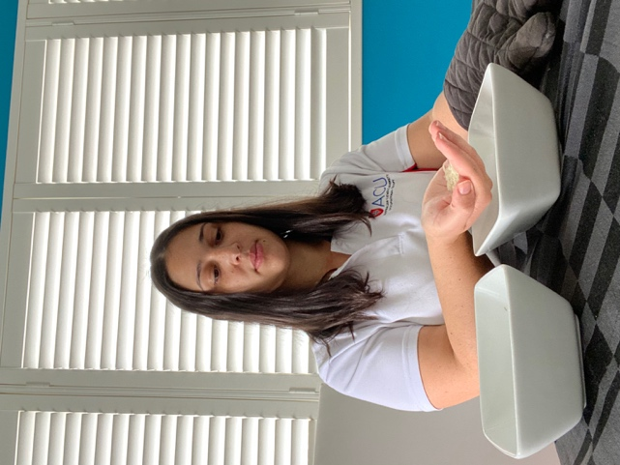 | How many handfuls of rice can you scoop up and drop in the bowl to your left / right in 30 seconds, without dropping any grains of rice? | - Increasing time goal to challenge endurance  - Moving bowls to incorporate other elbow and shoulder movements such as forward reach  - Not transferring rice to the other bowl but just scooping and letting go in the same bowl  - Allowing rice to be spilt until able to not spill any  - Lower edge to bowl  - Using Non-slip mat
Scooping soil in the garden | Forearm movement | - Pot plant/garden with soil and 1 x bucket/pot  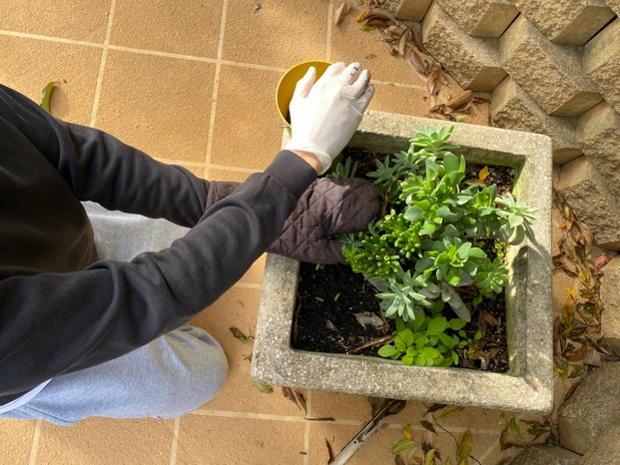  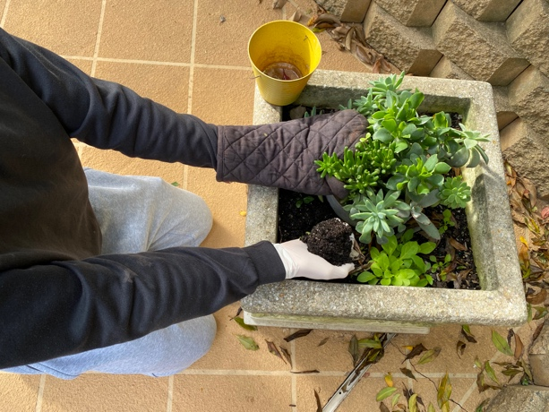  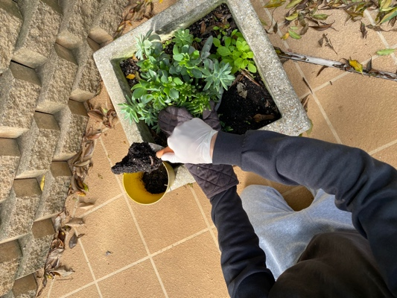  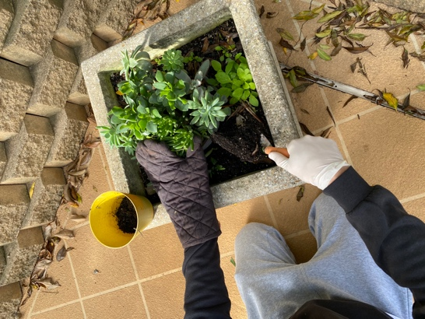 | How long does it take you to scoop with your hand all of the soil from the garden to the bucket/pot? | - Increase the amount of soil to be scooped and moved  - Progress to using a garden tool/spade (shown in picture)  - Start with just scooping the soil then progress to moving into bucket/pot when able
Task:  WRIST | Movement encouraged | Set up + equipment with picture | Original challenge/What to measure | Increasing / Simplifying the Challenge
Transferring small objects into container | Wrist control | - Container/bowl  - Small food items e.g. nuts, pasta, coins, dried beans or nuts and bolts into toolbox  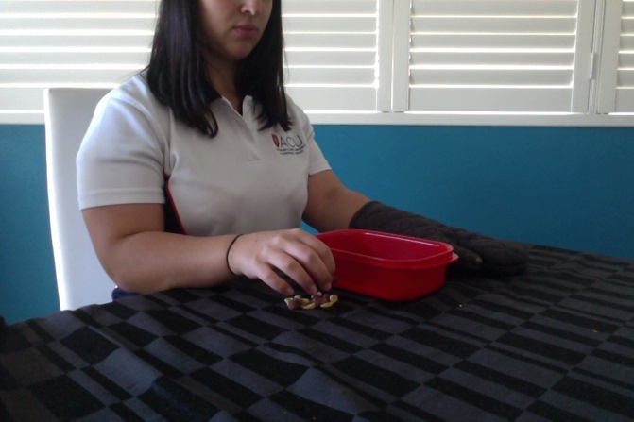  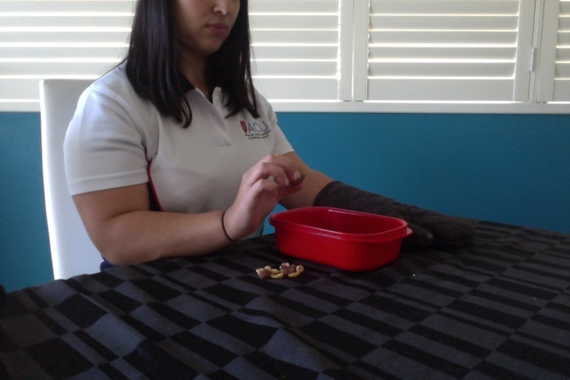  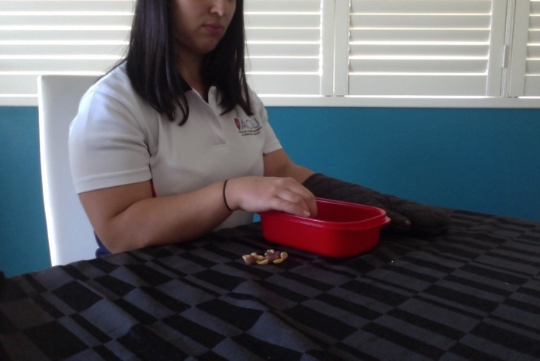 | How long does it take for you to transfer 10 nuts from the table to the container with only bending your wrist back and keeping your arm on the table? | - Use higher / lower container which requires wrist to bend further / less  - Increase number of food items to transfer  - Use container/bowl that requires less wrist movement  - Decrease number of items  - Isolate separate movements E.g. bending wrist forward to target on grid, bending wrist back to target on grid.
Moving magnets on fridge | Moving wrist back | - Fridge  - 5-10 x magnets (Alphabet magnets can work well)  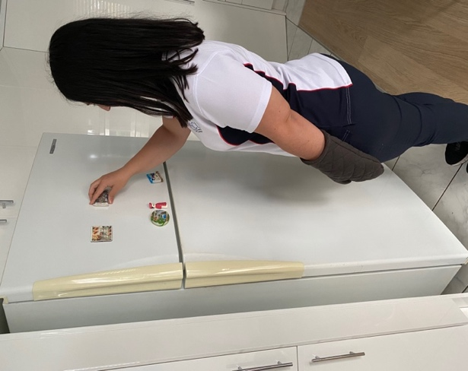  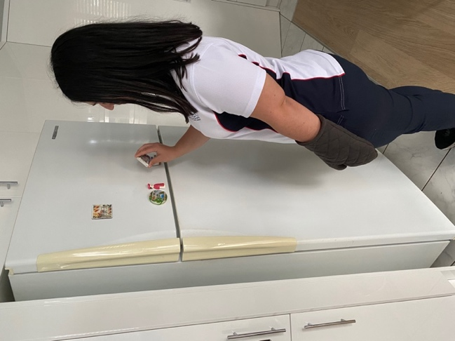  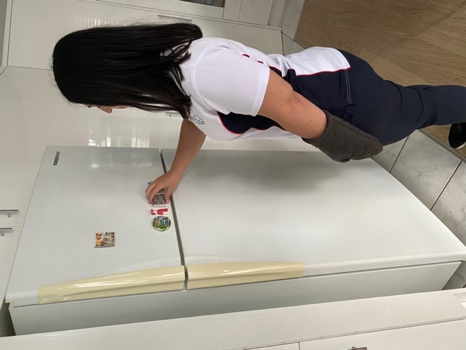 | How many fridge magnets can you move to a higher point on the fridge (the location specified by another magnet) in 45 seconds? | - Increase/decrease the time goal to challenge endurance  - Using stronger magnets that require more force to take off the fridge to challenge strength  - Higher point on fridge  - Writing longer sentences with alphabet magnets  - Using smaller magnets that require less force to remove them from fridge
Dot to dot | Wrist control  Bending / straightening wrist | Equipment: pen and paper  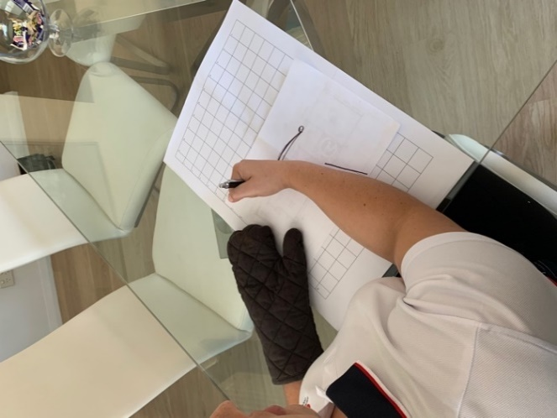  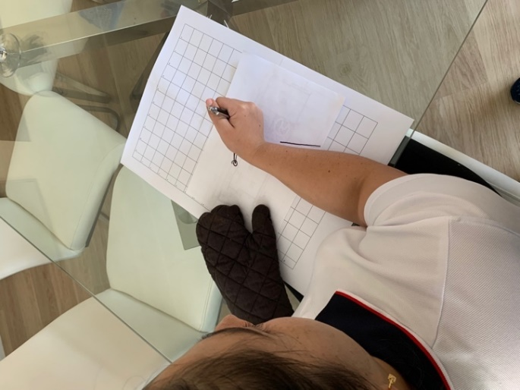  Set up: Hold pen in best grip available and connect the dots with the pen forearm steady on table | How many times can you connect the dots with just moving your wrist in 30 seconds? | - Moving the dots further away to encourage further wrist movement  - More complex dot to dot pictures  - Pen grip  - Allow any grip  - Some forearm movement  - Marker pen
Playing noughts and crosses on a white board | Bending wrist back | 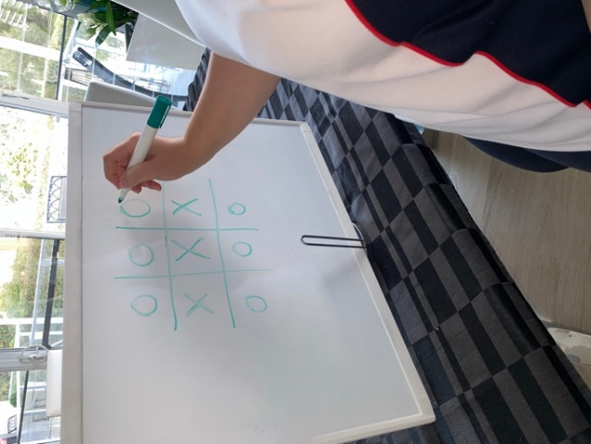  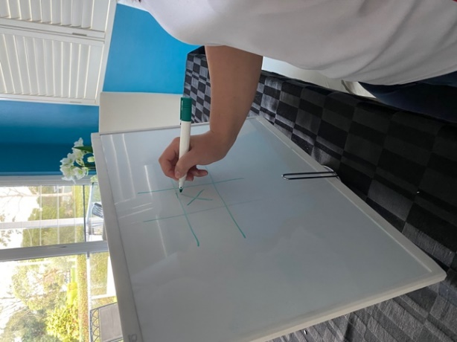  - Whiteboard set up at chest level + markers or paper to stick on wall at chest level | How many noughts and crosses grids can you draw in 1 minute? | - Small grids with small markers/chalk  - Using bigger grids and bigger marker  - Wider marker pen
Unscrewing lid of jar with whole hand/wrist | Wrist control/moving wrist from side to side | - Jar of food  - Grip mat or supporter to hold jar  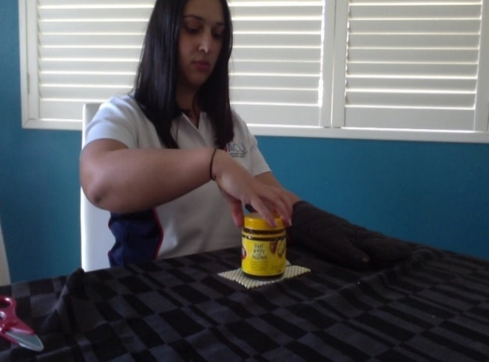  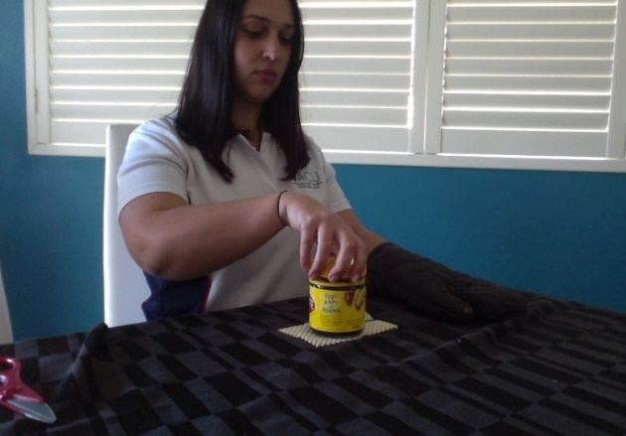 | How many times can you unscrew/screw the lid of the jar in 30 seconds? | - Increase repetitions e.g. in 45 secs  - Progress difficulty from easy to harder jars to open e.g. from vegemite to salsa jar  - Use jar with larger lid diameter  - Screw lid on very lightly
Lifting jar off table | Wrist control/moving wrist from side to side | - small container e.g; spice jar or small can of food  - forearm steady on table  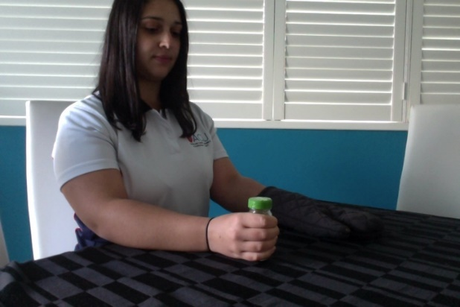  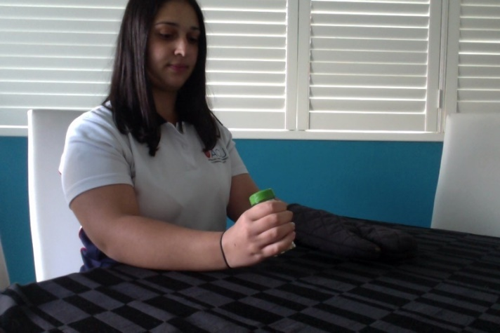 | How many times can you lift the jar up towards your body in 45 seconds? | - Using bigger/heavier containers e.g. can of food, empty vs full water bottle  - Incr./decr. time goal to challenge endurance  - Releasing grip in between each lift to hand flat on table  - Tipping to move coffee in bottom of mug  - Progress set up of task to incorporate simulating drinking from a cup – elbow bent, cup near mouth, bend at wrist to bring the “cup” to mouth
Task:  Grasp | Movement encouraged | Task set up and equipment | Original challenge/What to measure | Increasing / Simplifying the Challenge
Transferring small object from table to bowl with thumb and index finger | Pinching small items with thumb and index finger | - Small items e.g. pasta, grapes, cubes, nuts, dried beans, dominoes, hamma beads  - Bowl  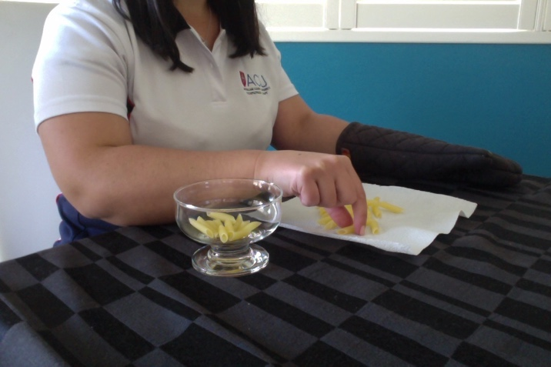  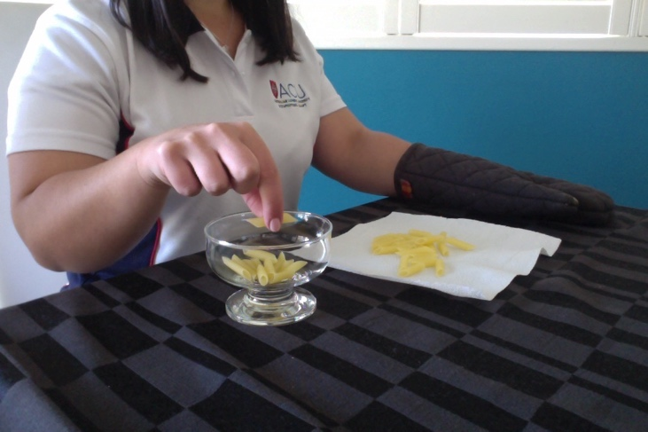 | How many pasta shells can you move into the bowl one by one with your finger and thumb in 1 minute? | - Increasing time  - Smaller or smoother object (e.g. marbles)  - Add in object to hold in palm to increase finger isolation e.g. picking up pasta one by one and once have five in hand, then release into bowl  - Changing size of object to suit client’s motor ability  - Use a low rimmed plate instead of bowl
Putting peg on side of container/ cup | Pinching small items with thumb and index finger | Equipment needed: pegs, container/cup  Line up pegs on line on grid and place container/cup in square on grid  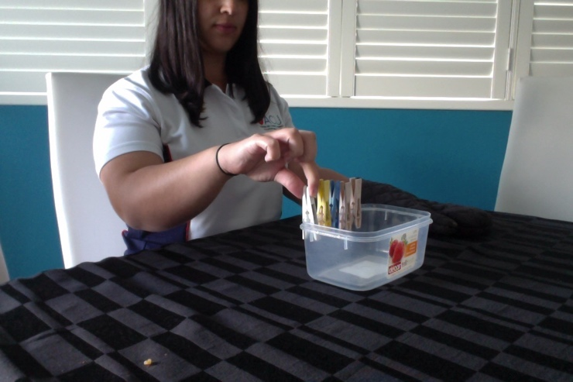  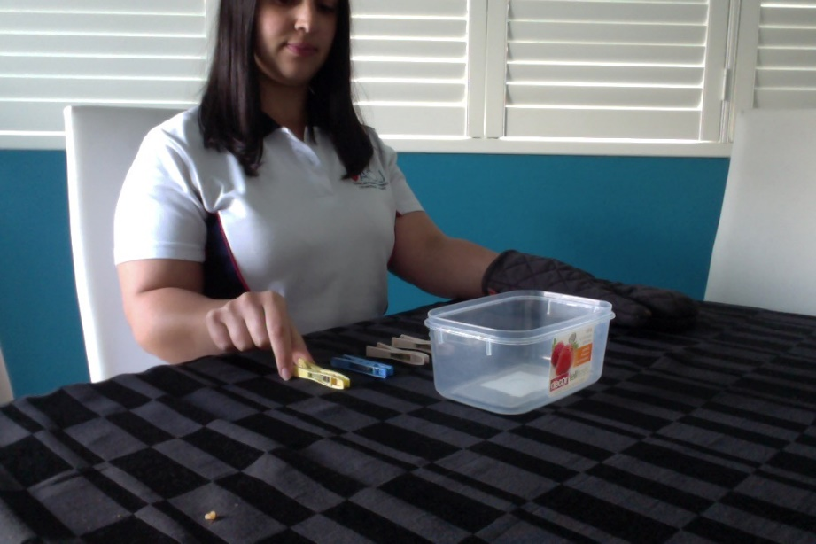  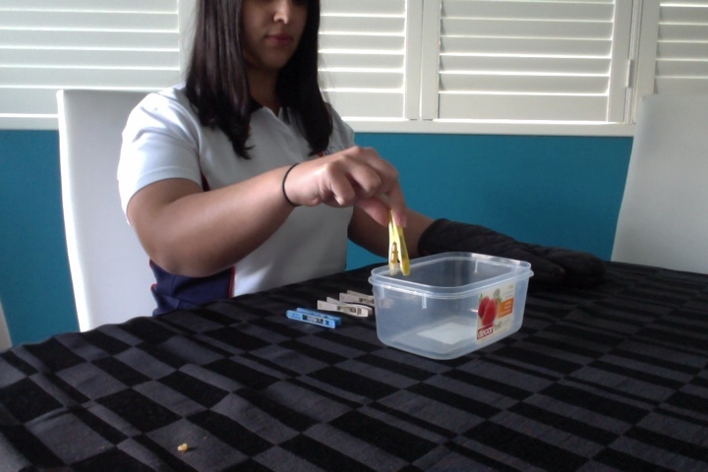 | How long does it take you to peg 5 pegs onto the side of the container and take them off again? | - Increase/decrease number of pegs to challenge endurance  - Add resistance onto the pegs with elastic bands  - Complete task in standing  - Put pegs onto a taller target e.g. clothes horse then washing line (or garden wire along fence)  - Weight can be added to container to stabilise  - Larger/less stiff pegs  - Larger container  - Move container closer to body  - Peg placed into client’s hand instead of picking up from table.
Playing chess/ checkers | Pinching small items with thumb and index finger | - Chess pieces and board  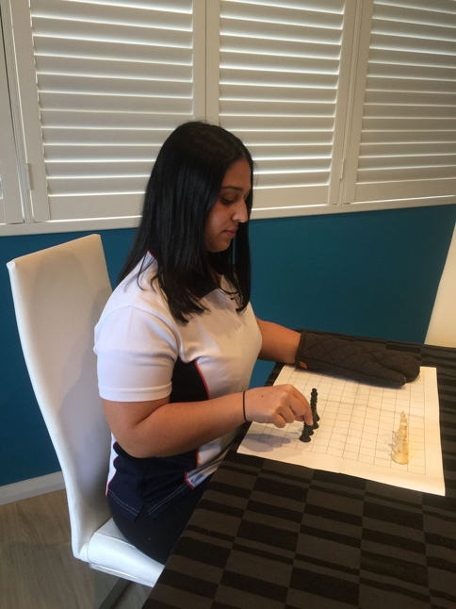  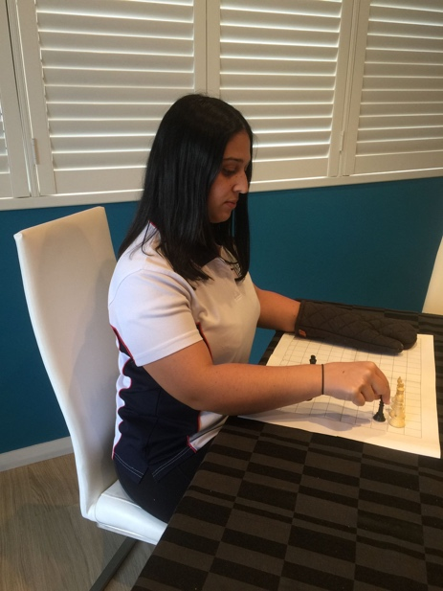 | How many checkers can you move forward 2 spaces on the board/grid in 30 seconds? | - Increase time duration to challenge endurance  - Introduce height/change target location to incorporate forward reach  - Lift pieces no sliding  - Using smaller chess pieces  - Stand up for task  - Slide /push pieces
Scrunching serviette/kitchen roll cloth and releasing into bin | Grip and release and strength | - Serviette/cloth x 5-10 (if available) or just one that can be reused (they can also be reused every time trial)  - Bin or other container e.g. ice cream container  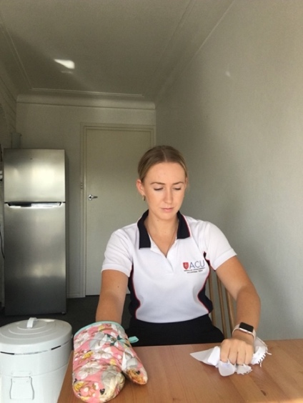  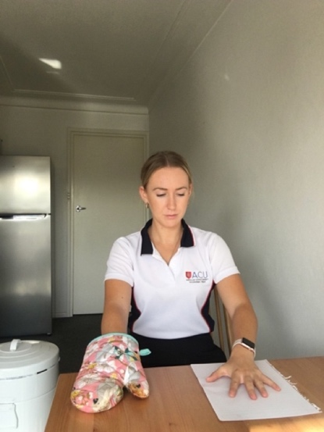 | How many times can you scrunch the serviette/cloth and place in the bin in 30 seconds? | - Type of material used (start with toilet paper or tissues, progress to cloth)  - Increasing time to challenge duration  - Move bin further away to incorporate shoulder movements related to person’s motor impairment  - Scrunch completely into hand so tissue can’t be seen!  - Standing throwing into bin
Squeezing water out of a sponge | Hand and finger movement/strength | - Sponge  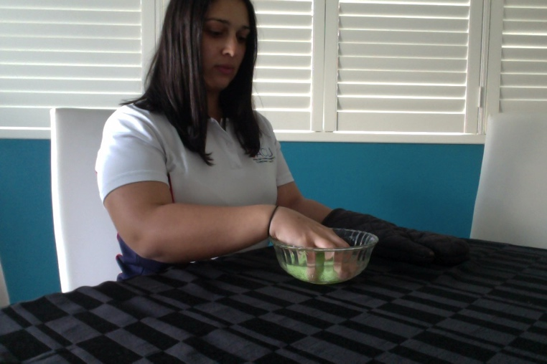  - Bowl with water  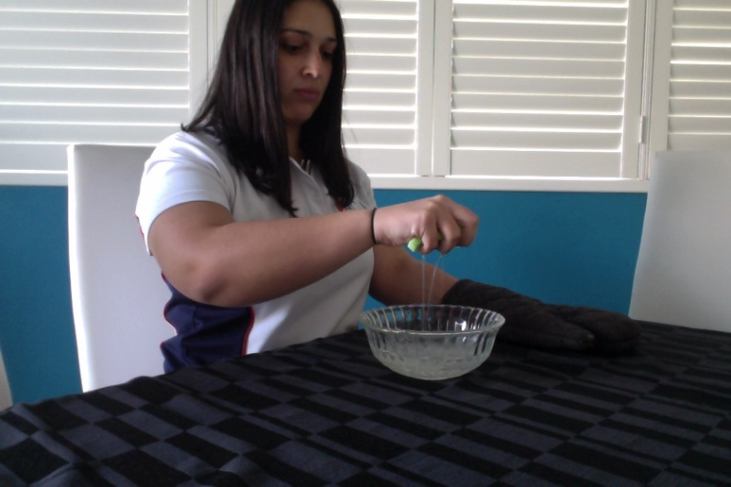 | How many times can you pick up the sponge from the water and squeeze all the water out in 45 seconds? | - Increasing/decrease the time goal to challenge endurance  - Using firmer sponge to challenge strength  - Any amount of water squeezed out allowed  - Keep hand on sponge – don’t let go in water  - Lower bowl
Moving objects in pantry/food cupboard | Hand and finger movement/strength | - Pantry/food cupboard  - Enough space to be able to move items from one side to another  - Could also be shelf in shed  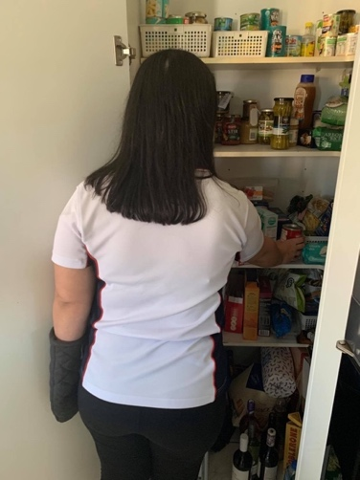  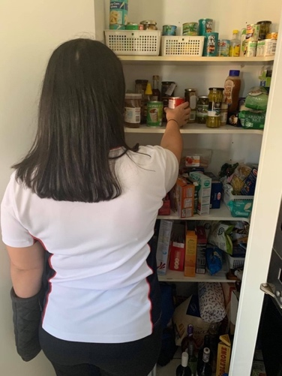  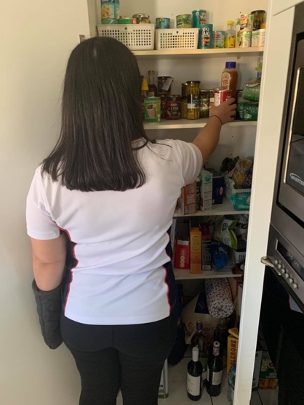 | How many items can you rearrange on the shelf in 60 seconds? | - Increase size of objects to be rearranged  - Aim for more repetitions in same time frame  - Increase weight of items  - Increase height of target shelves  - Decrease size of object  - Decrease weight of objects  - Add non-slip matting to object to make it easier to grasp  - Aim for lower shelf e.g. start at waist height
Using a fork to pierce a piece of food and move to another plate/bowl | Grip holding a fork and generating force to pick up food | - 1 x fork  - Food item cut up into small pieces e.g.; fruit or vegetables  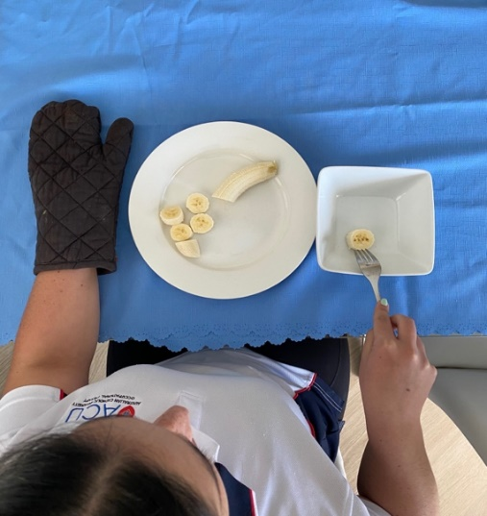  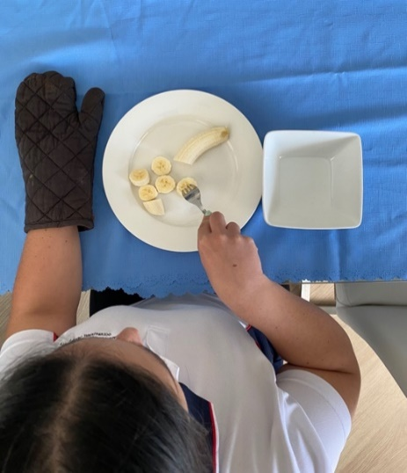  - You may need your supporters assistance in cutting foods up | How many pieces of food can you move from the plate to the bowl in 30 seconds? | - Use fruit items that increase the force needed e.g; start with soft food such as a ripe banana and progress to harder foods such as an apple  - Start with just piercing the food then progress to moving it when able  - Cut the food into smaller pieces to increase accuracy when piercing the food  - Increase/decrease time goal
Cutting food items using a knife | Grip holding a knife and generating force to cut food | - 1 x knife  - Food object that can be cut e.g; banana, apple, tomato, cucumber  - Supporter may be required to set up/stabilise food/safety reasons  - Alternatively you can use putty to simulate cutting food if you own it  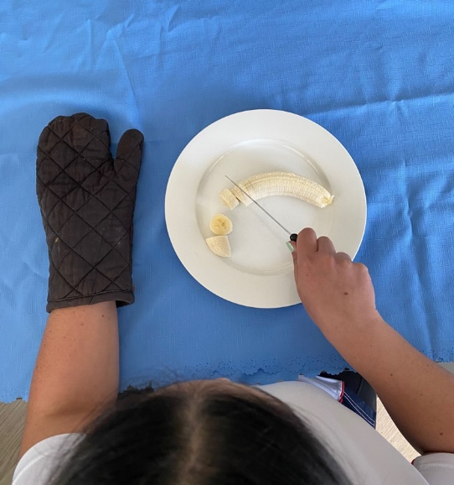  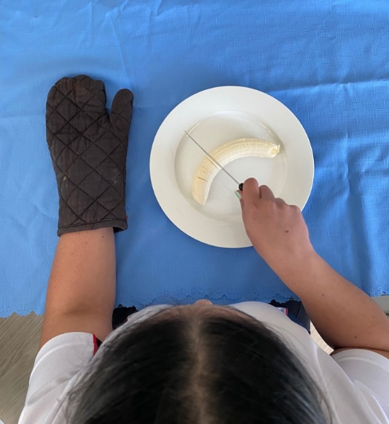 | How many slits can you make in the food with the knife in 30 seconds?  OR  How many pieces of the food can you cut in 30 seconds? | - Start with making slits in the food then progress to cutting pieces when able  - Start with softer foods e.g; banana and progress to harder foods e.g; apple  - Increase the time goal
Moving plastic cup/bottle without squashing it/changing its shape | Force control and gross grip | - 1 x plastic cup  - Alternately 1 x plastic bottle with water in it and marker. Make a rim around the bottle with the marker to make sure the water doesn’t cross that line (seen in pictures)  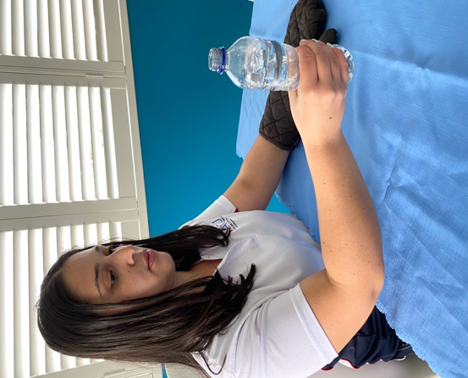  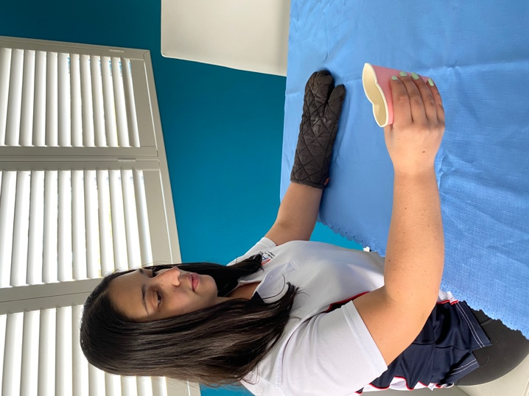  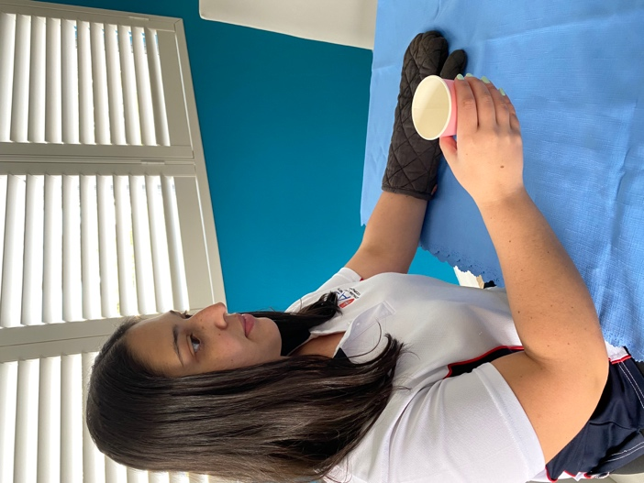  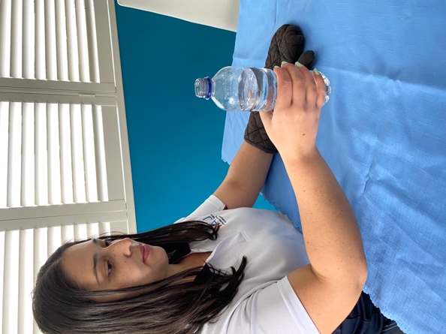  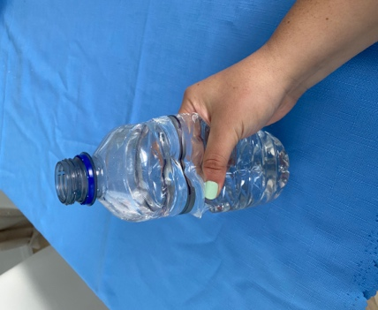 | How many times can you pick up and move the plastic cup/bottle without changing the shape or crushing it in 30 seconds? | - Increase/decrease time goal  - Allow small amount of shape to change then progress to no changing of shape of cup/bottle  - Start with just picking up the cup/bottle then progress to move it when able
Task:  Fingers | Movement encouraged | Set up + equipment with picture | Original challenge/What to measure | Increasing / Simplifying the Challenge
Screwing/ unscrewing water bottle lid | Using fingers and thumb to work together | - Water bottle  - Grip matt or supporter or put water bottle in between knees  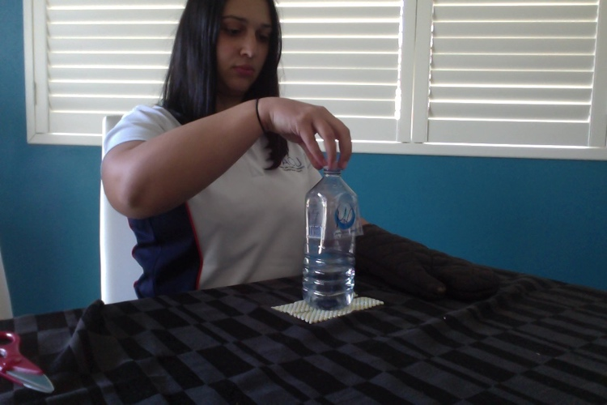  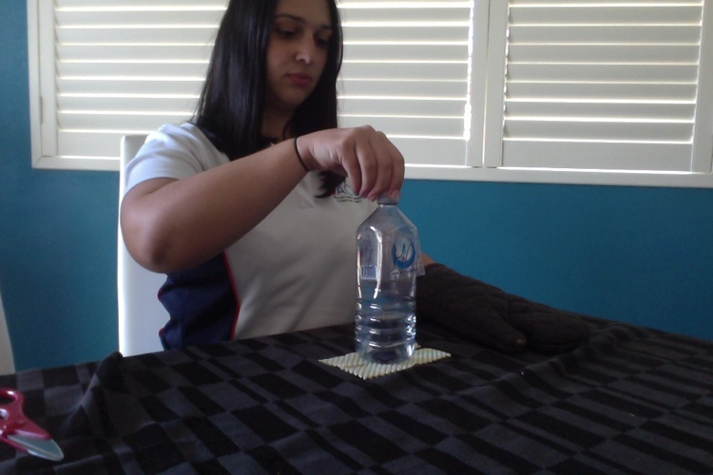 | How many times can you take off and put the lid back on using all of your fingers in 30 seconds? | - Increase duration to challenge endurance  - Use smaller lid  - Use less fingers and progress to add using more fingers when able  - Using larger lid  - Screw on very lightly  - Use smaller/shorter bottle  - Use rice or dried food inside bottle
Stretching elastic bands over can | Straightening out fingers | - Can  - Elastic bands  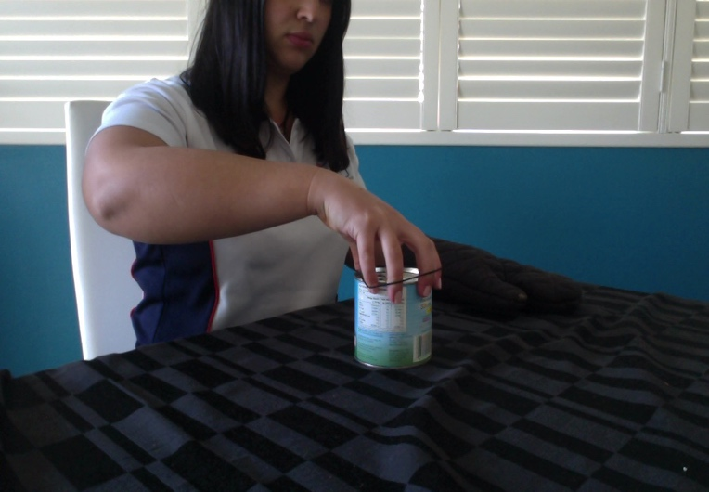  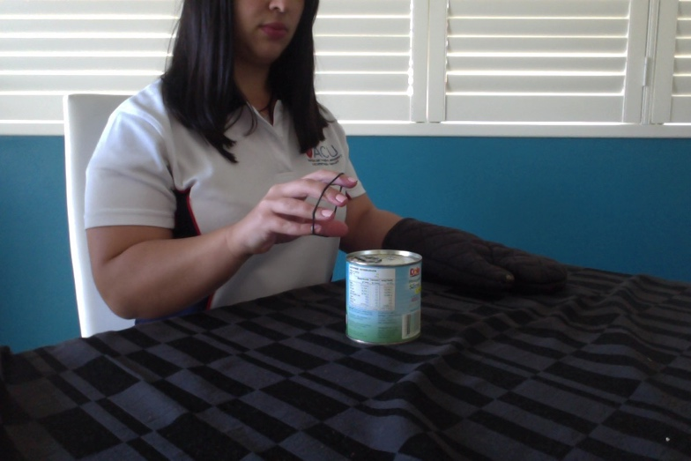  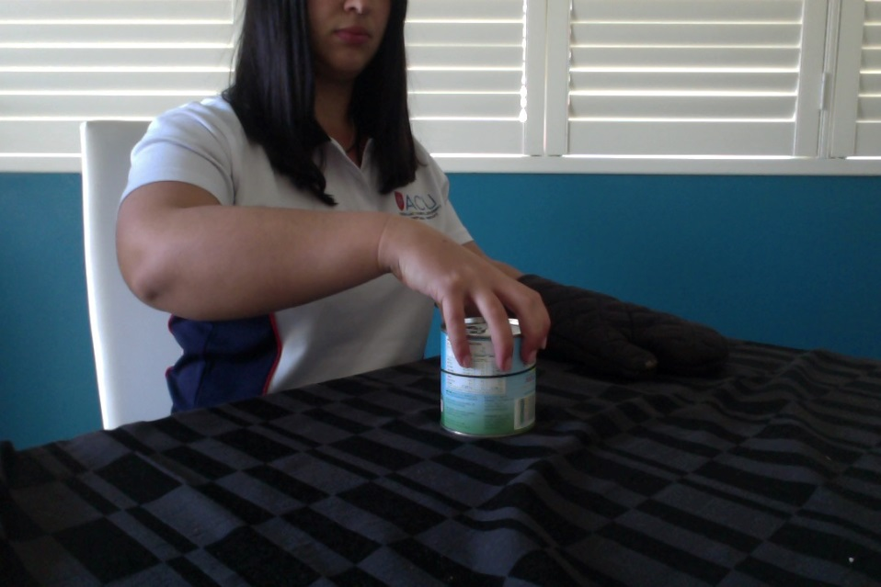 | How many elastic bands can you stretch over the can in 30 seconds? | - Increasing time goal to increase repetitions  - Increasing circumference of can  - Using an object with a smaller circumference  - Break down components e.g. stretching out elastic bands if unable to place over can.
Keyboard | Dexterity | 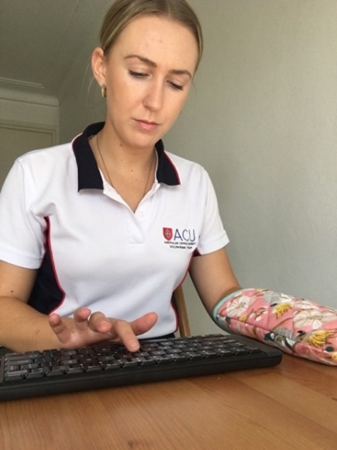  - Keyboard  - Rest your forearm on the table and do remove during task | How many times can you repeatedly press “kl” with your index finger in 30 seconds? | - Increase duration to challenge endurance  - Add in extra keys to type e.g. typing words “red”, “fred”  - Incorporate the use of other fingers when able  - Write short sentence  - Start with pressing one key repeatedly until able to progress  - Start using number pad only
Pressing buttons on calculator | Dexterity/ finger control | - Calculator or mobile phone  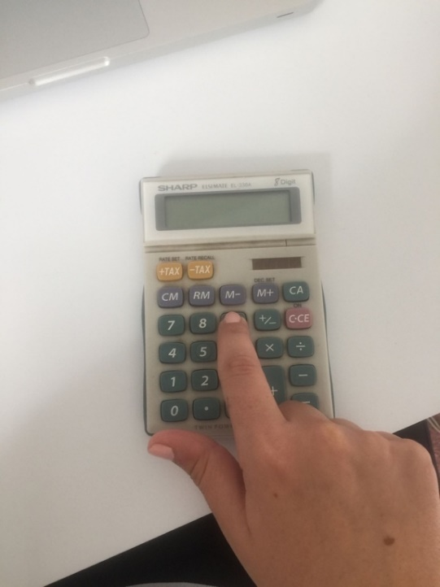  - Rest your forearm on the table and do remove during | How many times can you press 1-9 on the calculator in 30 seconds? | - Increase numbers they have to press/number patterns e.g. 1 + 2 =  - Increase time for endurance e.g. 1 min  - Pressing one number at a time until able to progress to more
Task:  Thumb | Movement encouraged | Task set up and equipment | Original challenge/What to measure | Increasing / Simplifying the Challenge
Pressing remote control buttons | Thumb control | - Remote control with buttons  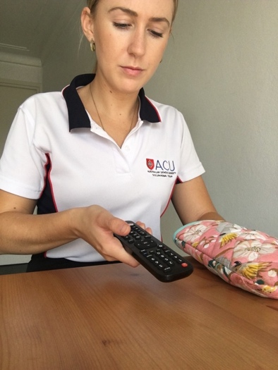 | How many times can you press 1-2-3 on the remote with your thumb? | - Add in extra numbers to press to increase thumb range e.g. 1-2-3-6-9-8-7  - Choose larger width remote control  - Specific codes / passwords in  - Any change of screen  - Reduce buttons to press to 1-2 or just 1  - Place remote control on your lap on a soft cushion so arm is supported
Sliding thumb across finger | Thumb control | 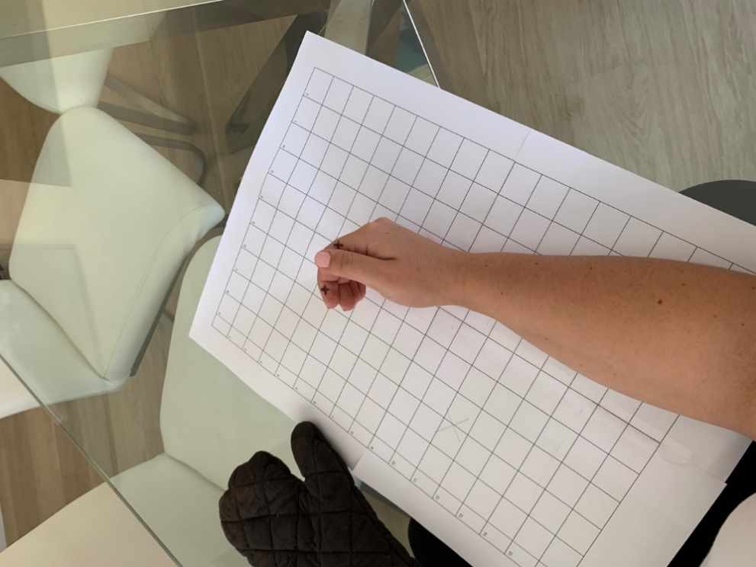  Equipment: pen/marker | How many times can you slide your thumb to hit both targets in 30 seconds? | - Increase/decrease range of targets  - Increase take duration to challenge endurance  - Combine with moving wrist back for functional grip and release
Moving thumb around small jar | Thumb control | - Small jar e.g. cinnamon shaker  - Marker to put ‘X’ on jar as target  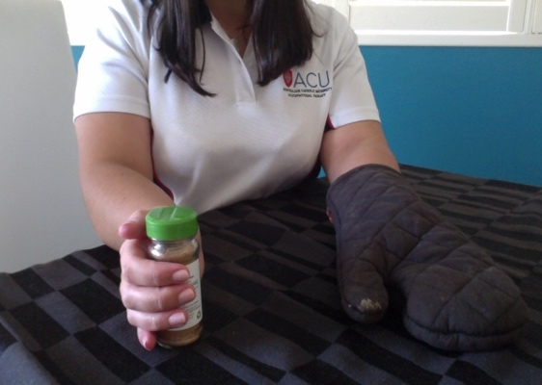  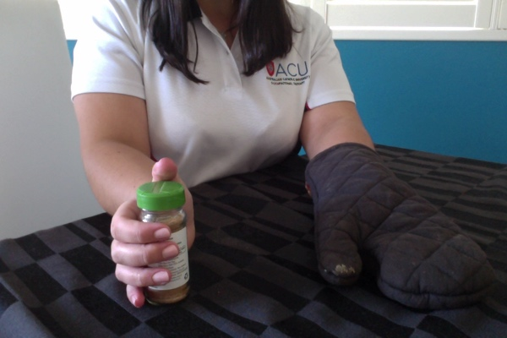  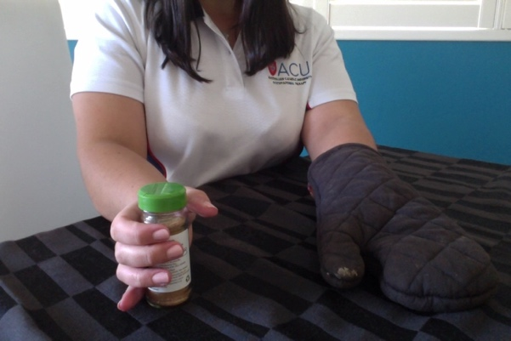 | How long does it take you to move your thumb around the jar to hit the target and back in 30 seconds? | - Move the ‘X’ target to increase range  - Increase time to challenge endurance  - Use larger jar e.g. can of food, jar of jam  - Using a smaller jar  - Moving target on jar to the top instead of the other side
Texting | Thumb control | - Mobile phone  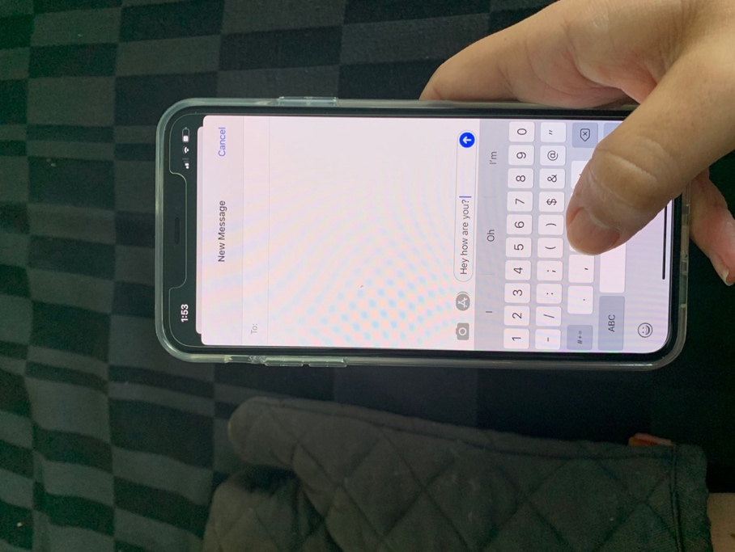 | How many words can you type in a text in 45 seconds? | - Increase/decrease the time goal to challenge endurance  - Do not rest arm/hand on table/any surface  - Including words that are harder to type – with letters and symbols that are located on edges of screen  - Start with a few letters/words in easier to reach locations e.g.; in the middle of the screen
Task:  In-hand manipulation | Movement encouraged | Task set up and equipment | Original challenge/What to measure | Increasing / Simplifying the Challenge
Stacking dominoes or  other objects | In hand manipulation | - 3 x dominoes or matchboxes or small sultana/nut boxes  Line dominoes up along line on the long flat edge. Stack in line on the short edge of domino  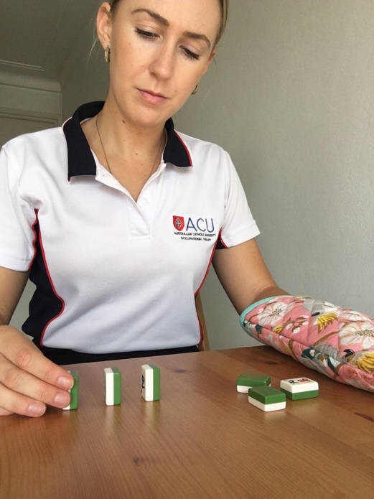  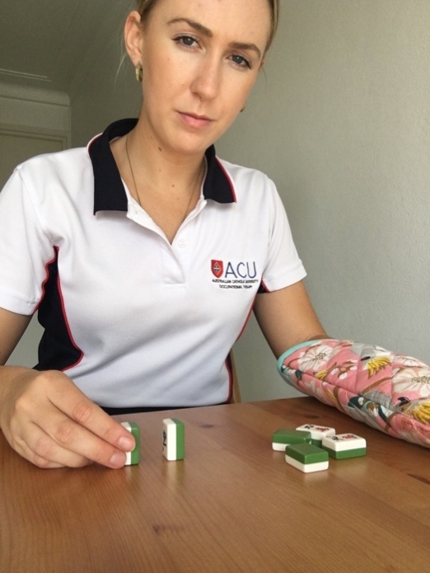 | In 30 seconds, how many dominoes can you pick up, turn around and stand up, using your thumb, index and middle finger? | - Add in extra rotations of domino to increase in hand manipulation  - Increase repetitions/ number of dominos to stack  - Changing size of object e.g. the smaller it is the harder  - Making a domino house (2 uprights, 1 across)  - Simplify  - Use any fingers to complete task
Rotating object in fingertips | In hand manipulation and fingers working together | - Matchbox or small sultana/nut boxes or any object of similar shape and size  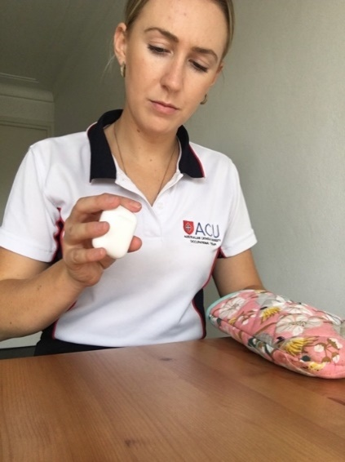 | How many times can you rotate the matchbox in your fingertips in 30 seconds? | - Rotate matchbox the other way  - Increase time and therefore receptions of rotations  - Use smaller matchbox to increase accuracy of manipulation  - Use heavier objects e.g. Chinese Boading balls.  - Start with half rotations  - Use larger objects
Posting matchsticks or toothpicks | In hand manipulation | - Match sticks and cup or toothpicks and toothpick container  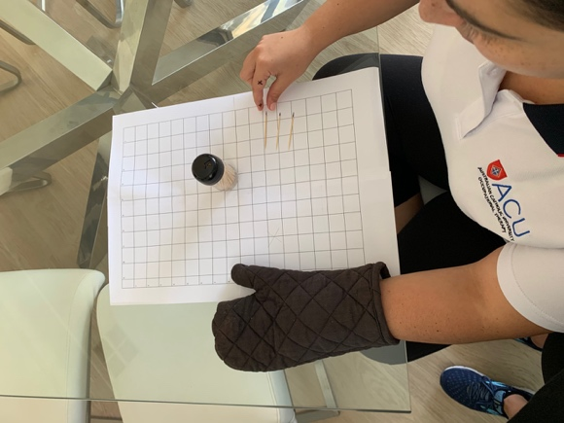  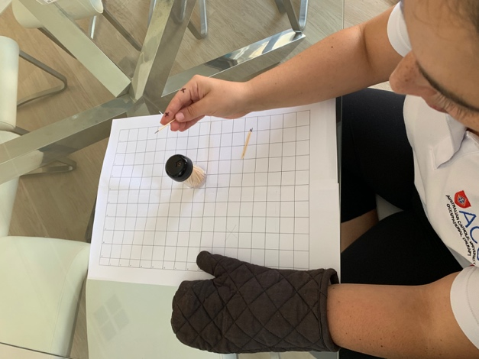 | How many matchsticks/ toothpicks can you post into the hole in 30 seconds? | - Increase time goal to challenge endurance  - Make size of hole smaller  - Start with larger sticks  - Use larger hole to post/ no lid  - Start with larger objects e.g. straws in a cup
Picking up pasta and holding in palm | In hand manipulation | Equipment: pasta shells, dried lentils, coins, small foods e.g. grapes, nuts  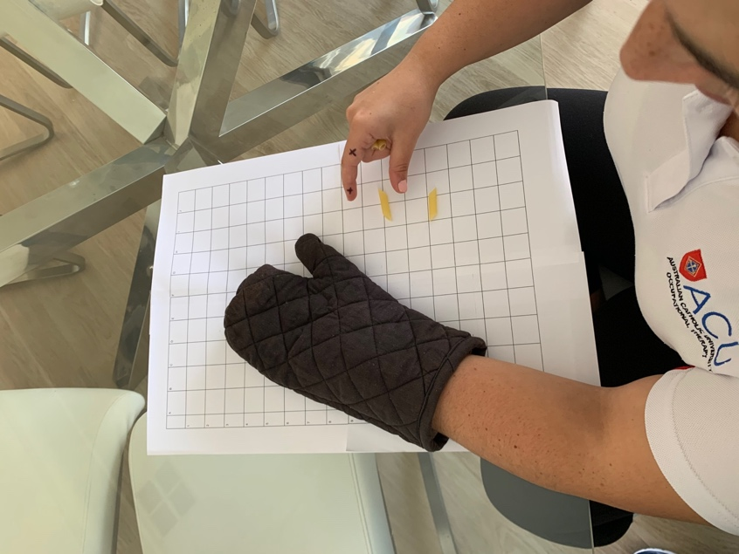 | How many pieces of pasta can you pick up and hold in your hand in 30 seconds? | - Use smaller pasta  - Increase number of pasta shells to pick up  - Bring pasta back to the tips of thumb and index finger then release instead of dropping the pasta from the palm of the hand  - Use marbles  - If using coins, can use a piggy bank  - Use easier shapes to grab  - Decrease amount of pasta to be picked up

