Participants will come up with their own task ideas to practise on their program, using the ‘Tasks I want to practice on the program’ sheet in the Preparation Pack. The below list serves as extra task ideas for both participants and therapists and gives examples of how to simplify and increase the challenge of various task practice ideas. You can copy and paste tasks (first 4 columns) directly into the participant’s ‘Task practice list’ in their Program Pack, and edit them as required. The ‘set-up’ column has been left blank for you to tailor the task to the participant’s abilities / their home environment. The ‘Therapist’s considerations’ box does not need to be copied. This highlights issues for therapists to consider.

When putting together the participant’s task practice list, the following is recommended:
- Around 15 tasks in total are chosen.
- A mixture of whole arm, dexterity and strength tasks are included.
- A mixture of reach, grasp and release tasks are used.
- Check that the participant has all the necessary objects/items to set-up and complete each task (write details in each ‘set-up’ box).
- Chosen tasks do not include too many activities normally done during daily living with the mitt e.g. washing, dressing, grooming, eating, drinking etc. Any of those activities added to the task practice list should relate to the participant’s goals, or their motivation to do extra practice. Ensure the participant is aware these tasks should be practised in addition to completing the activities during daily living with the mitt.

Task |  |  | Task focus |  |  |  | Set up |  | Ways to progress / simplify |  |  | Therapist considerations:
Folding laundry  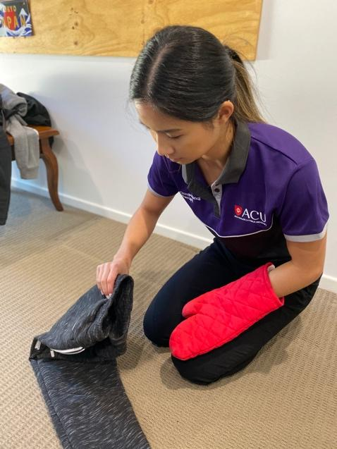 |  |  | Finger / thumb grip  Wrist control  Shoulder control |  |  |  |  |  | - Large / small items e.g. bed sheet vs tea towels  - Completed in standing / sitting  - On table / on lap  - Number of items folded / unfolded in 15/20 mins  - Holding in half vs in quarters or more neatly /roughly |  |  | - Good task for participants with less active movement. May help to increase stamina and improve standing ability for participants with less endurance
Unloading / loading dishwasher  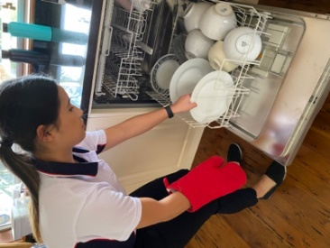 |  |  | Grasp / release  Whole arm activity  Shoulder and elbow control |  |  |  |  |  | - Putting objects in (gravity assist) versus taking out  - Stack higher / lower compartments of dishwasher  - Position of participant to the dishwasher  - Time it takes to load / unload  - Amount and weight of different objects  - Loading / unloading cutlery to increase challenge |  |  | - Consider using plastic items to stack / unstack initially, instead of ceramics or glass  - Discuss safety e.g. avoid knives sticking up vertically in cutlery holder
Task |  | Task focus |  |  | Set up |  |  | Ways to progress / simplify |  |  |  |  | Therapist considerations:
Putting or rearranging objects in / out of cupboard or fridge  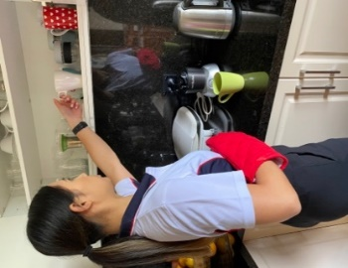 |  | Shoulder control  Strength  Stamina  Reaching  Grasping / release |  |  |  |  |  | - Higher / lower shelf  - Larger / smaller items (grasp width)  - Heavier / lighter items  - Complete cycle of task in less time / more time  - Standing position of participant to cupboard |  |  |  |  | - Size and shape of items will make a big difference to participants with less active movement  - If all cupboards are too high, start with lower level cupboards or surfaces e.g. onto boxes / books placed on work counter
Wiping down surfaces  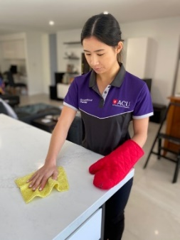 |  | Shoulder control  Muscles for reach |  |  |  |  |  | - Type of cloth or sponge used e.g. more / less friction or grip type required (sponge / jay cloth)  - Wiping in horizontal / vertical planes e.g. kitchen worktop vs cupboard or window  - Include / exclude squeezing cloth out  - Include / exclude spray bottle with water |  |  |  |  | - Falls / slips risk (consider water dripping on floor near participant)  - Ability to squeeze out cloth – may need supporter to act as the participant’s second hand to squeeze cloth out  - Consider fatigue vs positive challenge of doing whole task in vertical plane
Task | Task focus |  |  |  |  | Set up |  |  |  | Ways to progress / simplify | Therapist considerations:
Watering garden  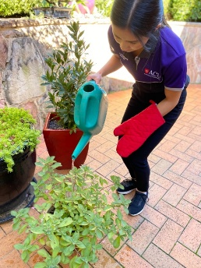 | Strength  Wrist movement and control |  |  |  |  |  |  |  |  | - Hose vs watering can  - Large / small watering can  - More / less water  - Higher hanging baskets vs low ground plants  - Number of pots or garden space watered | - Prior to assigning task, assess the participant’s safety during outdoor mobility with the mitt on, including how the participant accesses their garden  - Outdoor / dynamic balance  - Garden area assessed by therapist (advise participant / supporter to avoid doing any tasks on garden steps or unlevel surfaces for safety)  - Slips and trips hazards
Card games  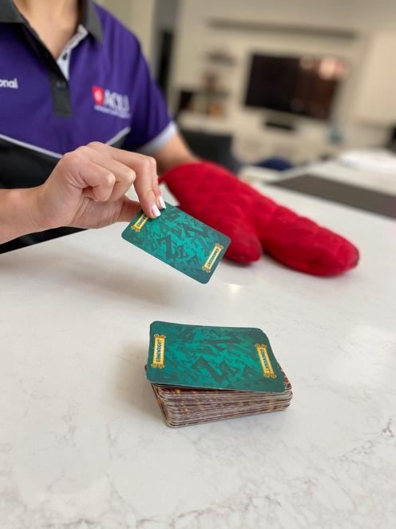 | Dexterity  Forearm control |  |  |  |  |  |  |  |  | - Choice of game: participant practising alone or with supporter / family member e.g. ‘Patience’, vs ‘Snap’.  - Participant could also sort cards into piles of suits or numbers | - Speed of game e.g. snap vs non-speedy game  - Cards placed further away/ closer to participant  - Amount of time it takes for participant to sort cards into suits (if not playing a game)  - Dealing out cards around table far away /near

Task | Task focus | Set up | Ways to progress / simplify | Therapist considerations:
Drawing / Writing with a pen  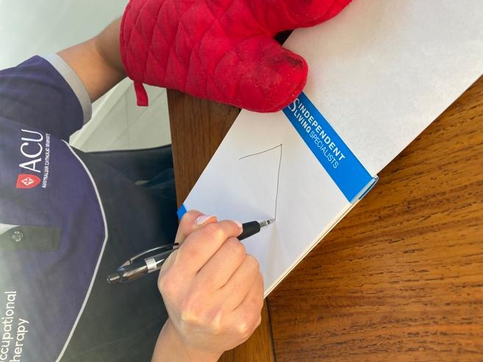 | Dexterity  Wrist control  Fine movement coordination  Pen grip and use |  | - Smaller / larger pens / pens with adapted grips  - Smaller / larger paper surface area  - Shapes / letters / words / paragraphs vs simple drawings  - Amount of words written in a set amount of time  - Write on lines vs plain paper  - Copying / tracing vs freestyle paragraph  - Horizontal vs vertical writing | - If you have a handwriting program already in place, can you use elements from this to guide the task?  - Consider type of grip being encouraged and why  - Include hobbies e.g. suduko or crosswords
Dusting  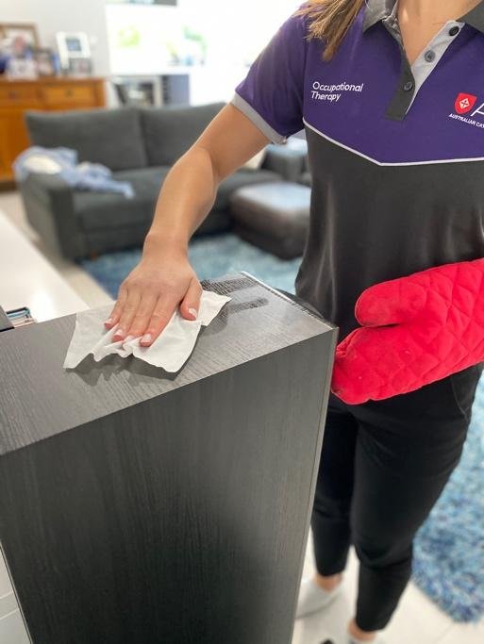 | Shoulder control  And / or wrist control |  | - Horizontal vs vertical plane  - Standing / sitting  - Low / high target  - Close / far (to body) target  - Objects vs surfaces | - Does the participant have a duster, or will they use a dry / damp cloth?  - Consider smaller objects to dust vs dusting surfaces
Task | Task focus | Set up | Ways to progress / simplify | Therapist considerations:
Unpacking shopping  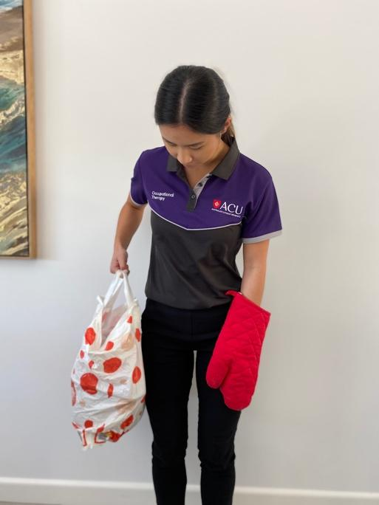 | Strength  Elbow and shoulder control  Grip strength |  | - Putting away into cupboards / onto work top  - Low cupboards / high cupboards  - More/less items in bag  - Shopping bag on floor /chair  - What height they pick bag up from e.g. chair or floor  - Whether they mobilise with shopping bag short distance before putting into cupboards | - Safety mobilising – should this task be done in standing or is it safe to incorporate walking into the task also?  - Build up amount of shopping in the bag slowly
Connect 4 (or similar game)  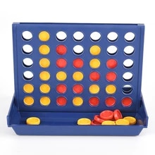 | Dexterity  Reach  Coordination |  | - Place target further away vs close to participant  - Games with smaller counters vs larger counters  - Rest counters on table vs bowl to pick up from  - Picking up counters from a slippery surface vs from a non-slip mat | - Good task to practise if coin tasks are too challenging  - Can make competitive to increase engagement

Task | Task focus | Set up | Ways to progress / simplify | Therapist considerations:
Sorting change  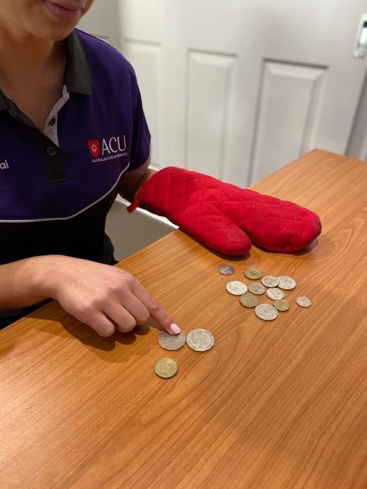 | Manipulating objects  Holding multiple small items  Dexterity |  | - Smaller / larger coins  - Where picking coins up from e.g. bowl vs table  - Worktop / table to pick up coins from vs non-slip mat  - How picking up e.g. sliding coins to edge of table / picking up directly from table  - Where putting coins e.g. wallet, piggy bank  - Height of target  - Larger / smaller container (e.g. bowl / slot)  - Done in sitting or standing | - Consider aim of task and parts that participant can achieve, e.g. picking up or manipulating into hand, dealing with multiple coins vs one at a time, ability to position coin to place in target e.g. piggy bank  - Supporter can hold open wallet if taking change in and out of wallet
Painting  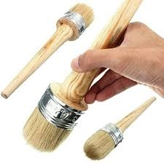 | Forearm control  Wrist control  Strength / stamina |  | - Horizontal vs vertical painting e.g. setting up at table or work top on paper / cardboard  - Larger vs small brush strokes  - Roller vs paint brush | - Set up of task to reduce drips and splashes (could it be done in the garden)  - Supporter may be required to help set up / put away task  - Create targets on paper for participant to paint from and to

Task | Task focus | Set up | Ways to progress / simplify | Therapist considerations
Clearing out / cleaning cutlery drawer  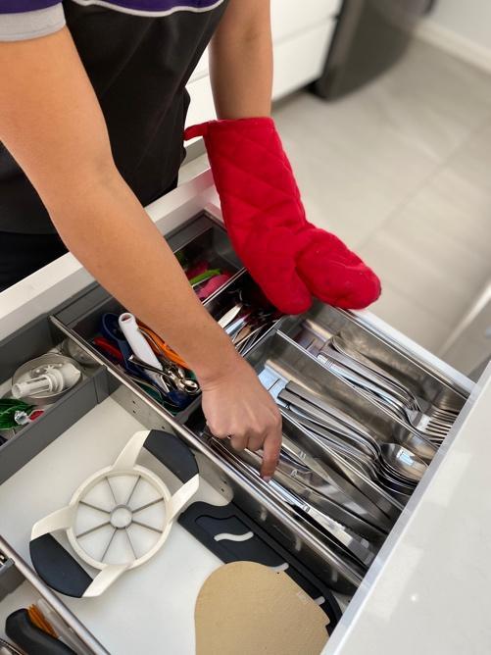 | Dexterity  Grip  Forearm control |  | - Knives / Spoons  - Amount of cutlery in drawer when removing an item  - Can they pick up from work surface or need non-slip mat or tray  - Plastic versus metal cutlery  - Heavier vs lighter cutlery | - Cuts risks with knives  - Placement of cutlery in drawer  - Could pick up the head end of spoons initially
Sorting your toolbox  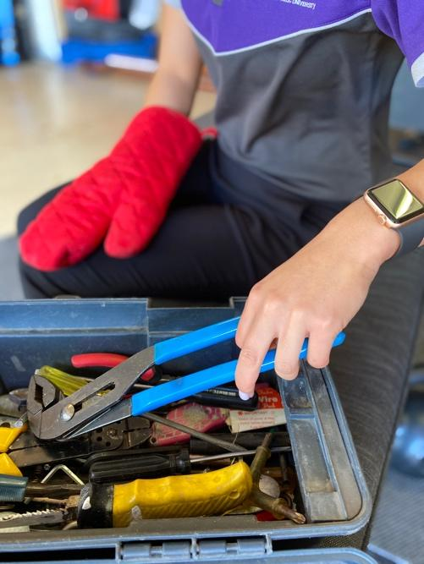 | Grip and release  Whole arm task |  | - Smaller items/ easier to grab items  - Heavier items / lighter items  - Inclusion of smaller DIY items such as nuts, bolts, screws  - Sitting / standing  - Toolbox on floor vs table | - Consider safety of contents of toolbox e.g. rusty nails, sharp blades or objects which could cut

Task | Task focus |  | Set up |  | Ways to progress / simplify |  | Therapist considerations
Mobile phone use  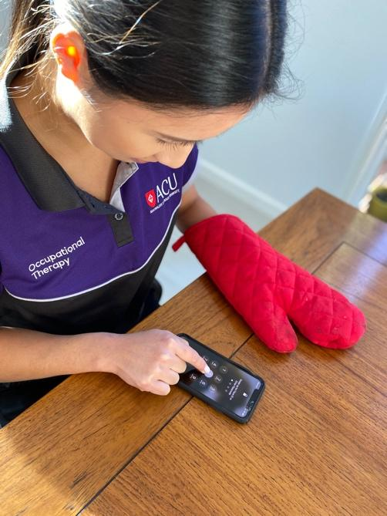 | Thumb control  Manipulating objects in your hand  Turning your palm to face upwards |  |  |  | - Standing / sitting  - Elbow unsupported / supported  - Complex games / simple games to reach target with thumb vs texting  - Time it takes to write a message / number of sentences written or proportion of paragraph copied in given time frame e.g. 15 minutes  - Swipe vs single movements |  | - Width of mobile phone  - Participant’s use of mobile phone – what is most useful e.g. games, messaging, calling etc.  - Participant’s ability to manipulate phone one-handed to set the task up (supporter assistance required?)  - Put onto airplane mode for practice  - Is there an app available to work on thumb control e.g. a game?
Cleaning the car  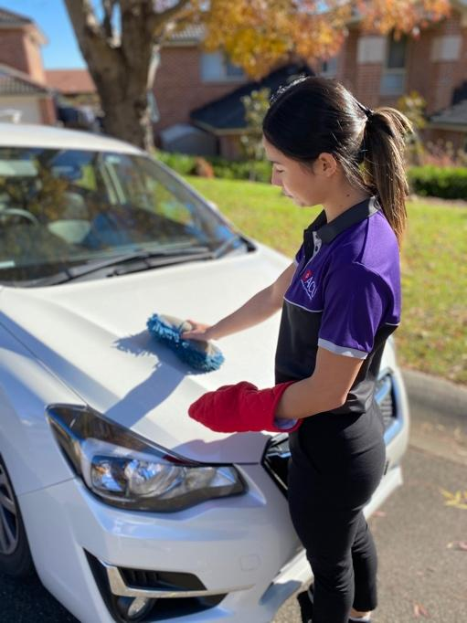 | Whole arm task  Strength / endurance  Balance |  |  |  | - Sitting (inside) vs standing  - Without/with stabilising through mitted hand  - Far/close targets e.g. steering wheel sitting inside car vs roof of car in standing  - Time it takes to complete one side or part of car e.g. door  - Top of car vs bottom of car |  | - Complete a risk assessment of outdoor mobility using mitt including how participant accesses outdoor area  - Is supporter required for set up?  - Inside of car (e.g. tidying / wiping) vs outside of car (washing / polishing)  - Participant’s dynamic balance  - Slips risk if water involved – footwear for task
Task | Task focus |  | Set up |  | Ways to progress / simplify |  | Therapist considerations
Potting plants  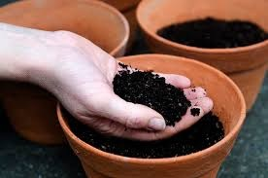 | Wrist control  Gross grip |  |  |  | - Small pots vs large pots  - Amount of time it takes to fill a pot with soil  - Amount of pots which can be filled in a set amount of time  - Sitting / standing |  | - Does participant have spare soil, pots, trowel? If they do not, but the task is motivating to the participant, can a similar task be set up?  - Set up can be messy. Supporter to help + put away.  - Consider where the task is going to be carried out e.g. sitting at a table vs on the floor  - Complete a risk assessment for outdoor mobility using mitt including how participant accesses outdoor area
Getting in and out of car (including shutting and opening car door)  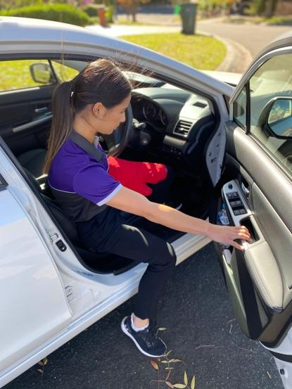 | Whole arm activity  Strength |  |  |  | - Heavier / lighter car doors  - Unlock and open door / door left ajar  - Passenger or driver’s side  - Get in front and back seats on one side vs both sides  - Include other car tasks, putting windows up/down, operating radio/moving seat forward /back |  | - Complete a risk assessment for outdoor mobility using mitt including how participant accesses outdoor area  - Complete task on a level surface to avoid door shutting by itself on participant
Task |  | Task focus |  | Set up |  | Ways to progress / simplify |  | Therapist considerations
Playing Ball with A Racket  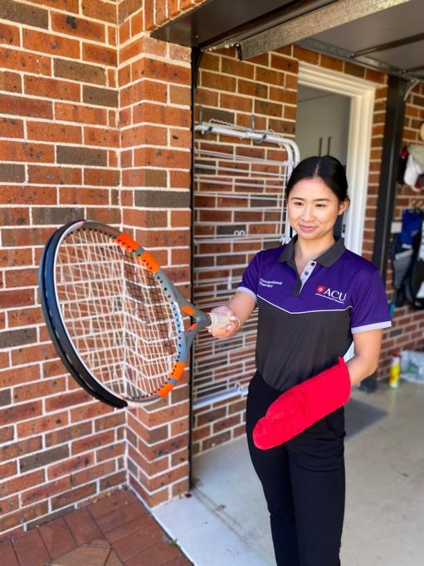 |  | Co-ordination  Whole arm control  Hand-eye  co-ordination  Strength |  |  |  | - Games where aim is to keep ball in the air (bouncing), games against wall/supporter throwing ball and collecting ball  - Small ball vs large ball  - Hard ball e.g. tennis ball vs soft ball e.g. sponge ball  - Throwing and catching with hand including against wall, no racket  - Increase length of task e.g. from 15 to 20 minutes to build endurance/ regular rests |  | - Complete risk assessment for outdoor mobility using mitt including how participant accesses outdoor area  - Advise participant / supporter to clear uncluttered floor space to practise in  - Complete task on level ground, preferably grass, with no trip hazards  - Supporter / family member could play to increase motivation for the task
Playing Lego / Duplo (or any game with small toys)  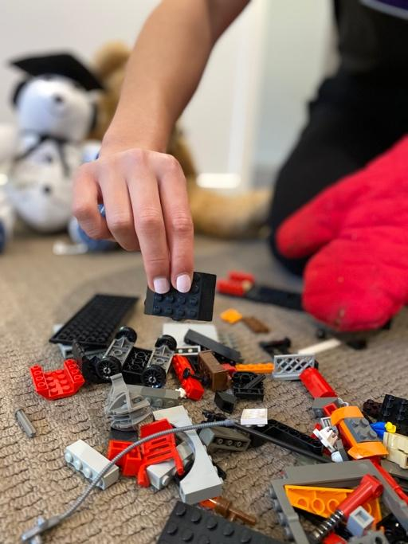 |  | Dexterity |  |  |  | - More challenging body position e.g. sitting on floor / sitting on chair with blocks at a lower height vs sitting at table with toys on table  - Smaller / larger pieces  - Children’s games for ease of instruction |  | - Get other family members involved / children / grandchildren, source kit from charity shops or borrow from family / friends
Task |  | Task focus |  | Set up |  | Ways to progress / simplify |  | Therapist considerations
Using the remote control to change channels on the TV  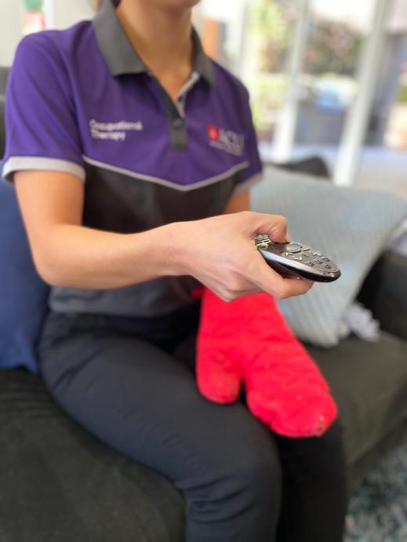 |  | Dexterity / Thumb control |  |  |  | - More complex tasks e.g. entering passwords or codes, changing channel to supporter request / any change of channel  - Standing / sitting with remote supported on lap  - Big button / small button remote control |  | - This task could be used as a precursor to participant using their thumb in mobile / cell phone task
Flower Arranging   |  | Whole Arm, Dexterity |  |  |  | - More advanced arrangements / few stems  - Work top / low table  - High or fragile vase / wide non-breakable vase placed in sink  - Vase filled with water / no water  - In standing / sitting |  | - Whether supporter presence is required

Task | Task focus | Set up | Ways to progress / simplify | Therapist considerations
Reading a magazine/paper   | Whole arm  Finger / thumb control |  | - Magazines / board books with thicker pages e.g. children’s books or pages in a novel or magazine  - Amount of pages turned in a set time  - Turning from front to back or back to front | - Encourage participants to find reading material of interest / favourite magazines  - Consider set-up e.g. in sitting / on lap
Weeding  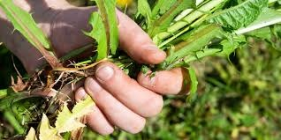 | Grip and arm strength |  | - Body position: crouching / kneeling / in sitting  - Long handled tools / short handled tools vs no tools  - Area of garden weeded in certain time frame | - Complete risk assessment for outdoor mobility using mitt including how participant accesses outdoor area  - Consider safety moving around garden including whilst carrying tools with mitt on

Task | Task focus | Set up | Ways to progress / simplify | Therapist considerations
Setting a table  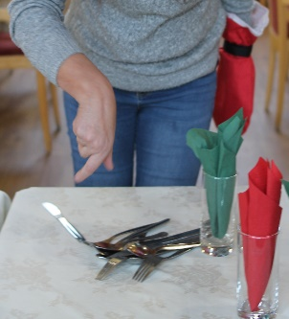 | Whole arm activity / dexterity |  | - All tasks involved vs only one set task involved e.g. pushing chairs into table, laying cutlery, folding, and positioning serviettes, putting glasses out / one element  - In standing or sitting | - Encourage completion of task without leaning through mitted arm
Using a spoon to scoop items  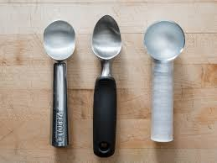 | Dexterity,  elbow control |  | - Use of regular cutlery / adapted cutlery or other e.g. wide handle, bendy spoon, plate guard, non-slip mat  - Transferring water from bowl to bowl vs dried beans (can use custard consistency in between)  - Bringing spoon to mouth / bowl to bowl only, basic stirring | - This task can be completed in addition to eating during daily life with mitt hours to increase the amount of practice. Or you may set the task as part practice if the complete tasks is too challenging initially

Task | Task focus | Set up | Ways to progress / simplify | Therapist considerations
Using a fork  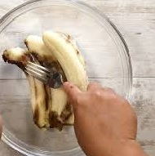 | Dexterity, elbow control |  | - Whole task vs part task e.g. piercing / stabbing food, mashing, picking up food items, bringing to mouth  - Using different food textures e.g. banana, putty, cheese, pasta, noodles etc.  - Bowl to bowl transfer only, heavy bowls to add stability | - This task can be used in addition to eating during daily life with mitt on for additional practice or may be completed as part practice when the whole task is too difficult  - Theraputty (‘putty’) or playdoh can be a useful alternative to practising with food
Cutting/chopping with a knife  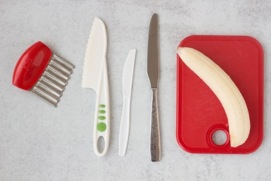 | Dexterity, elbow and shoulder control, grip strength |  | - Standard cutlery knife /adapted knife, pizza wheel /spatula  - Slightly harder fruit or veg/ softer e.g. banana or other food such as baking dough  - Different knife skills – chopping, cutting, spreading | - Consider safety – observe task to assess and minimise risk. Utilise non- slip maps or adapted chopping boards as appropriate  - Do not use sharp kitchen knives  - Theraputty (‘putty’),playdoh or clay can be a useful alternative to practising with food

