Useful items to increase use of the weaker arm

The TIDE team have found the following items helpful at times within CIMT programs, to increase the use of the weaker arm whilst the stronger arm is in the mitt.

These items can:

* Make an activity ‘do-able’ with the weaker arm, rather than too challenging or impossible e.g. drinking from a doughnut sports bottle for those who cannot pick up a glass.
* Reduce the use of the mitted hand as a stabiliser e.g. non-slip mat.
* Make an activity one handed rather than two-handed e.g. elasticated waist band rather than buttons and zips on trousers.

Encourage the participant to also try out different items already within the home that can be used during the program, for example cups with different handles, items with a different weight/material, in order to find an item that can be used well with the weaker arm.

Food and Drink Items

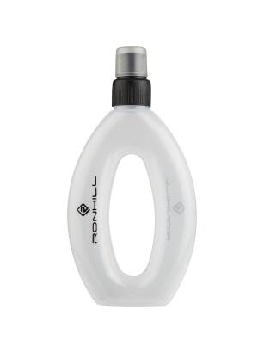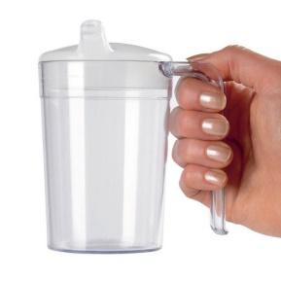 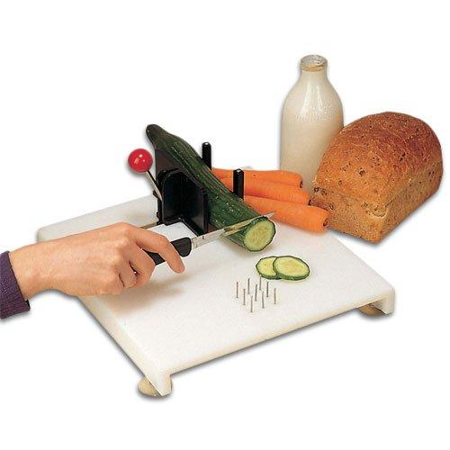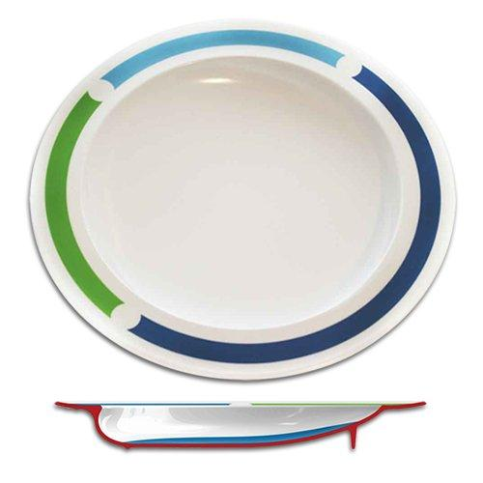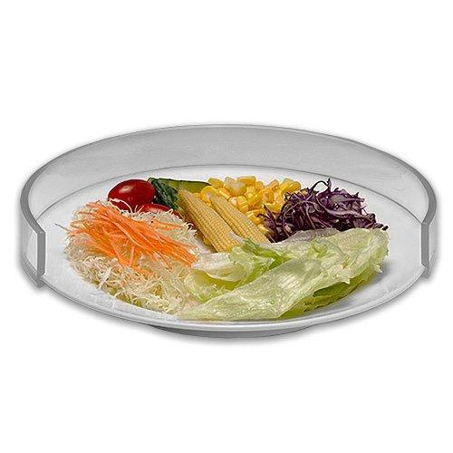 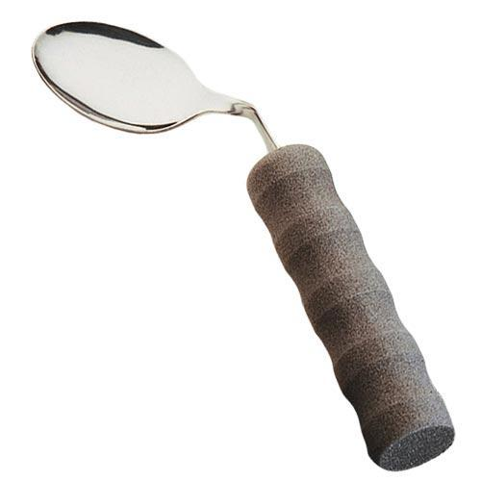 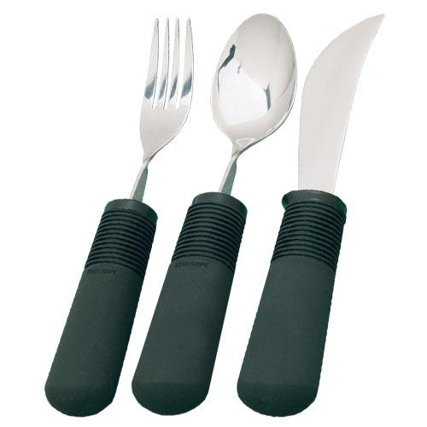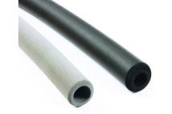

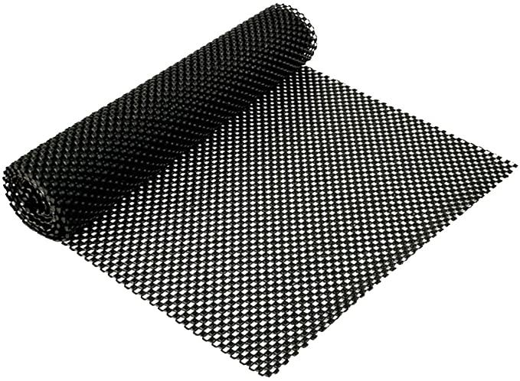 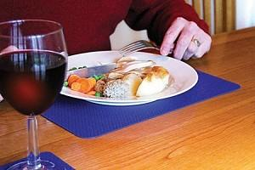 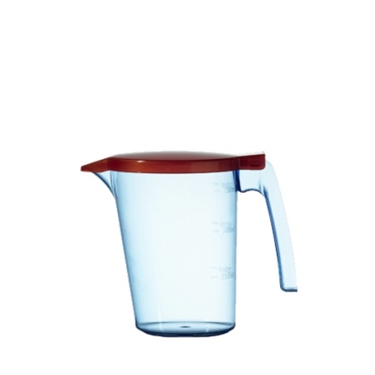

Dressing and Self Care Items

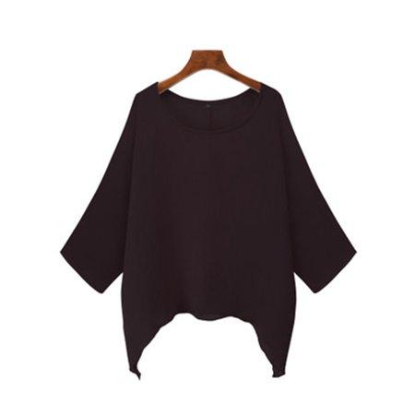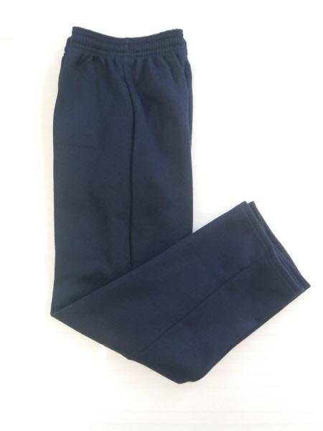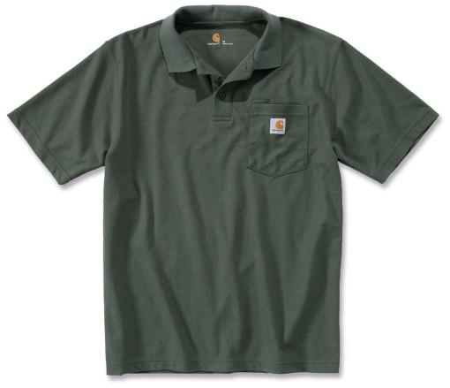 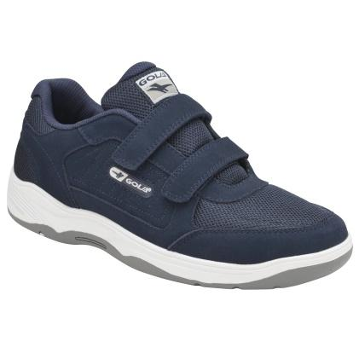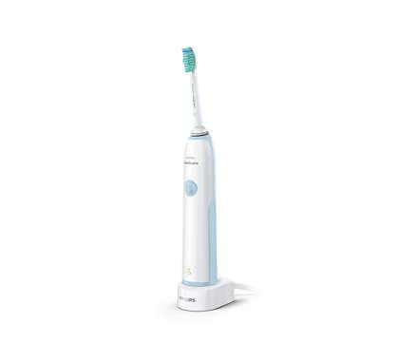

Shopping and Carrying

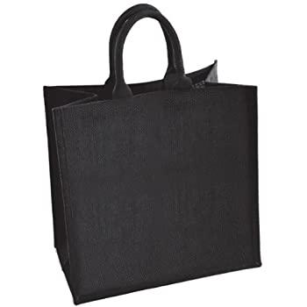

Writing

